cedesk@port. ac.uk

IT Training
Information Services

servicedesk@port.ac.uk

Version 1
May 2018

ISTR FINREP

e5 Reporting

Table of Contents
DATA PROTECTION 1
INTRODUCTION 2
What is e5 reporting 2
General security 2
Security 2
Accounts 2
Contacts and Information 2
ACCESS AND NAVIGATION 3
Logging on 3
Login Screen 3
Login 3
Log Out 3
Home Page 4
Recently Viewed Items 4
Popular Resources 4
Ad Hoc View/Reports/Dashboards 4
Toolbar 4
RUN A REPORT 5
Access a report 5
To run a report 5
Example report parameters 6
Report Output 6
Change report parameters 6
Return to Library 7
Export report 7
E5 REPORTS 8
Access reports 8
Navigation 8
Reports 8
Run an E5 report 9
Example report parameters 9
Report Output 9

DATA PROTECTION
The e5 reporting system holds personal data about individual members of staff in relation to salaries. This data should be processed in accordance with the General Data Protection Regulation 2018, and should not be disclosed to third parties except in certain circumstances, an example of which is given below.
The e5 system is password protected for security reasons and for that reason you must not share your password with anyone else. Only certain members of staff have the ability to change data and this access control should not be altered without good reason, following documented procedures. The procedures are documented in the finance manuals. You should not leave your computer logged onto the e5 system for any length of time and you should always remember to lock your computer whilst you are away from your desk.
There will be very few situations where data needs to be provided to a third party. In most instances, the member of staff whose data is to be shared should be asked for their consent before the proposed disclosure is completed. There are situations where we may be under obligation to provide the data eg if it is requested by an auditor or if providing the data may be in the public interest. It would be appropriate still to inform the member(s) of staff whose data is to be disclosed prior to the disclosure. Any disclosure should be recorded in case it is queried at a later date.
It should be noted that it is an offence under the General Data Protection Regulation 2018 to knowingly or recklessly disclose personal data. Individuals may be personally liable for such an offence. If you are unsure whether to disclose any data, check first with your manager or the University’s Data Protection Officer, Samantha Hill.
If you have any queries about the Data Protection Act and how it affects your work, please feel free to contact the Samantha Hill on x 3642 or look at the University web pages on data
protection at www.port.ac.uk/DPA.
May 2018

INTRODUCTION

What is e5 reporting
The e5 financial management system is used by the University to provide an integrated solution to various finance-related needs. These include statutory financial accounting, management accounting and budgetary control, aiding the procurement process, payment of suppliers, employee expenses, and supporting credit control functions.

e5 reporting enables staff to run a variety of reports against the data held in e5 and access to the reports will depend on staff roles.

General security

Security
The e5 reporting system has extensive security to provide an audit trail of activity which can be monitored.

It is important that the system, and the data held on it, are used responsibly and in accordance with the procedures determined by Finance and under no circumstances should a user’s account
be shared.

Accounts
Access to the system will be enabled by Finance when the appropriate training has been
successfully completed. Each account will be set up with access to the appropriate reports.

Contacts and Information
The IT Training webpages provide a wide variety of information relating to the University’s Corporate Systems. This information includes:

- IT Training contacts
- Appropriate Finance, Department of Student and Academic Administration (DSAA) & Human Resource contacts
- Resources, e.g. the latest versions of each manual

ACCESS AND NAVIGATION

Logging on
Based on a standard University build PC.
Mac users should contact the Finance Systems team for advice by emailing finance.system@port.ac.uk.
Launch the e5 Reporting app from AppsAnywhere.

Login Screen
Figure 1
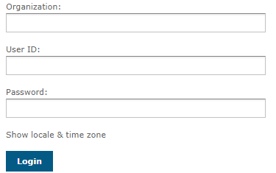

Login
Organization | Enter the code for the company you are running the report against. This will normally be UP for University of Portsmouth. Contact Finance if you need to run against an alternative company code.
User ID | Enter the same ID as e5. This will include your department and initials. New users will be given their ID
Password | Enter the password
 | Select

Log Out
Select from the Toolbar

Home Page
The first page displayed after login is the ‘Home’ page. Access will depend on the user’s role.
The window is split into three areas.
Figure 2
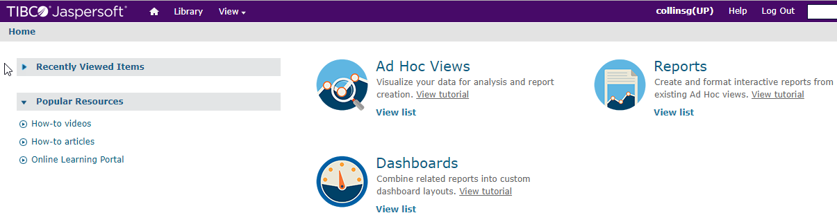

Recently Viewed Items
The most recently viewed reports will be listed. Select a report to re-run it.

Popular Resources
Not in use

Ad Hoc View/Reports/Dashboards
Not in use

Toolbar
The following functions are available:
Select the ‘Home’ button to return to the Home page
Select the Library button to give a full list of your reports
Select the View button to access the Repository and see the reports analysed by folder
Select to log out

RUN A REPORT
Users will have access to reports that are relevant to their roles.

Access a report
The Library holds a full list of relevant reports
Select from the toolbar

Figure 3

To run a report
Report | Select a report
Input Control window | Enter the parameters in the available fields. These will vary by report. The parameter fields for some reports may default.
 | Select
 | Select

Each report has the SQL report number in brackets.

Example report parameters
Input Controls for report - Range of transactions by cost center, nominal, period & year against balance class A* (SQL 64)
Figure 4
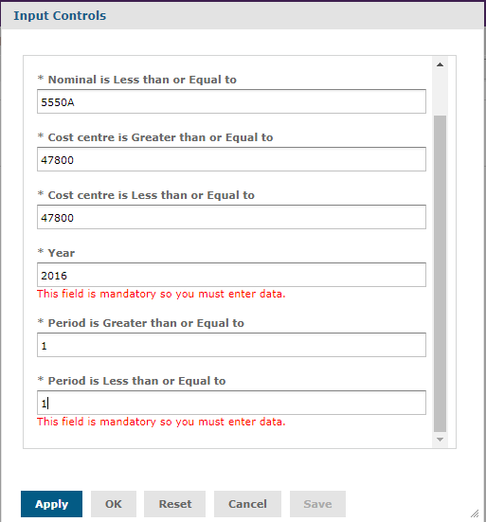

Report Output
The report output will be returned.
Figure 5
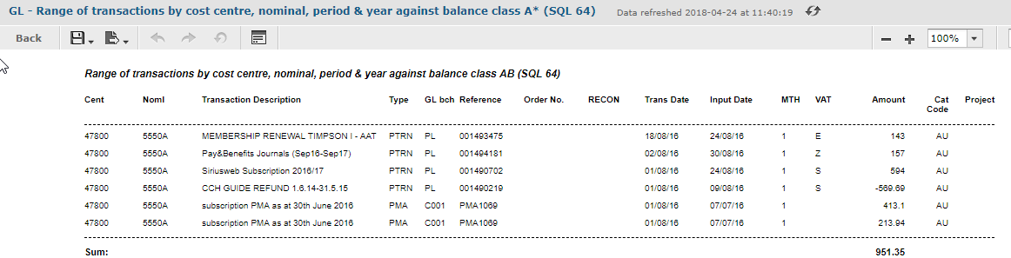

Change report parameters
 | Select and the Input Control window will be returned
Parameter window | Make changes to the parameters
 | Select

Return to Library
Select from the toolbar

Export report
Reports can be exported to other formats.
Select the dropdown arrow next to Export and select from the following output options.
Figure 6
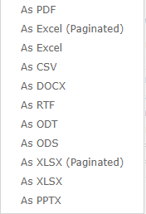

E5 REPORTS
There are three further reports held in e5. These reports can be used for additional information that was available in sequel (SQL) reports 59,64,65 but is not visible in the e5 reports.

Access reports

Navigation
Logon to Finance System (e5) → Menu → E5 reporting
Figure 7
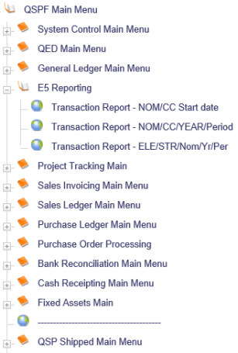

Reports
E5 report | SQL report
NOM/CC Start date | SQL report 59
NOM/CC/YEAR/Period | SQL report 64
ELE/STR/Nom/Yr/Per | SQL report 65

Run an E5 report
E5 reporting | Select one of the three reports
Mapping Parameters | Enter the parameters in the available fields. These will vary by report
 | Select

Example report parameters
Parameters for – Transaction Report – NOM/CC/YEAR/Period (SQL report 64)
Figure 8
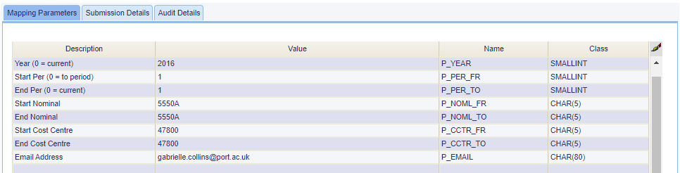
The report will be sent to your email address.

Report Output
Example output for SQL report 64
Figure 9
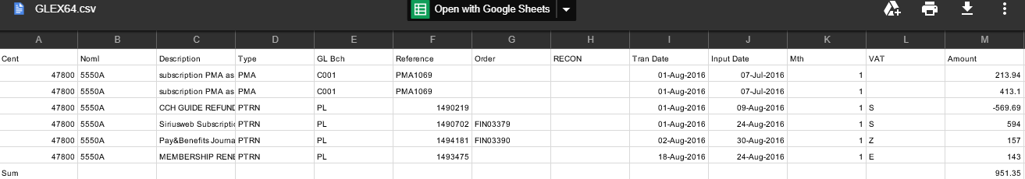
In this example the Order field has been populated.

Block 5
Second Floor
St. Andrew’s Court
St. Michael’s Road
Portsmouth
PO1 2PR

