cedesk@port. ac.uk

IT Training
Information Services

servicedesk@port.ac.uk
Paperclip

Version 1
July 2018

Table of Contents
INTRODUCTION 1
Using Paperclip 1
Process to attach a document 1
Process to open, review and close a document 2
Process to download a document 2
Process to delete a document 3
Process to view notes to an attachment 3
Related Document 4

INTRODUCTION
Paperclip is a tool that allows users to attach electronic documents to an order list, supplier details and transactions. They can then be viewed by other users in the system.
Most standard file types are supported and some can be previewed in the Paperclip screen. Word, Excel, PDF and text files are typical.
There is no limit to the number of documents that can be attached but there is a 2 Mb (2048 Kb) limit per file. This is sufficient for a large Word or PDF document.

Using Paperclip
Wherever you see a Paperclip toolbar button or see a paperclip column in a list view on a screen you can attach files. If an order/record has an existing attachment, then a paperclip will be displayed to the left of the record.
Figure 1
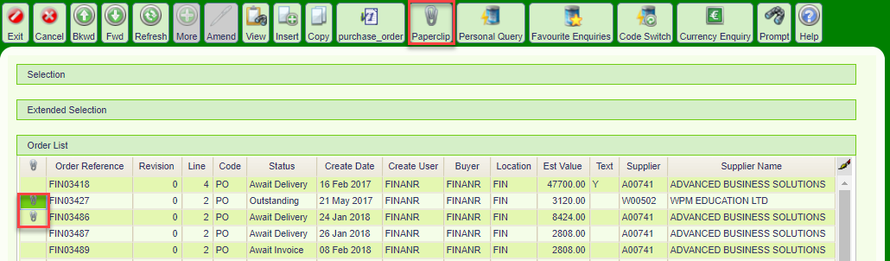

Process to attach a document
Order List Select a record
Select the paperclip button
Select the ‘Choose file’ button and navigate to the file
Attach File Select the file and click ‘Open’
Notes Type notes in the box under the ‘Choose file’ button
Attachment Visibility Will default to Public. Select from the dropdown menu. See table below
Click to upload the document

Visibility | Description
Public | All users can see this document
Sensitive | Only users in the security groups can view sensitive information
Public View\Sensitive Update | Visible to all users but cannot be changed

Process to open, review and close a document
Order List Select a record
Double click on the paperclip icon on the record line
Paperclip pane The Paperclip pane will open and display any attachments. See figure 2 below
Review Document Highlight the attachment and click the magnifying glass to review the document in the preview pane or right click over the attachment and select ‘Preview Document’ from the menu. See figure 2 below
Click to close
Figure 2
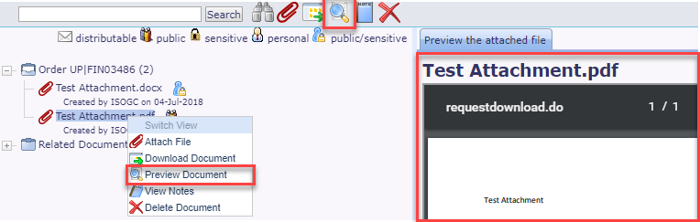

Process to download a document
Highlight the attachment and click the Download icon on the toolbar or right click over the attachment and select Download Document from the menu. See figure 3 below
Figure 3
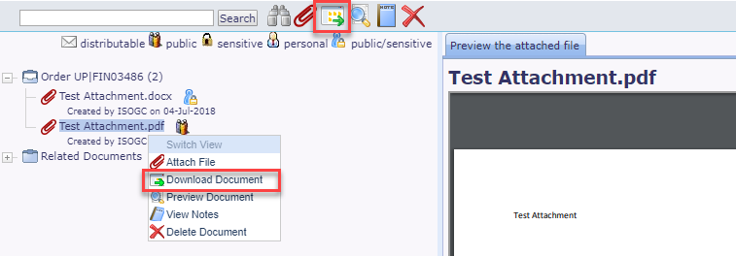

Process to delete a document
Attachment Highlight the attachment and select the cross in the toolbar or right click over the attachment and select ‘Delete document’ from the menu
Figure 4
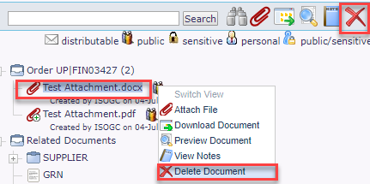

Process to view notes to an attachment
Paperclip pane Highlight the attachment
Click the ‘View Notes’ icon or right click over the attachment and select View Notes. See figure 4 and 5 below
Figure 5
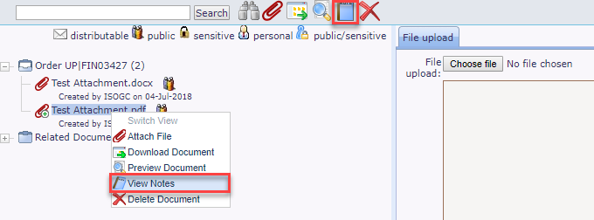

Figure 6
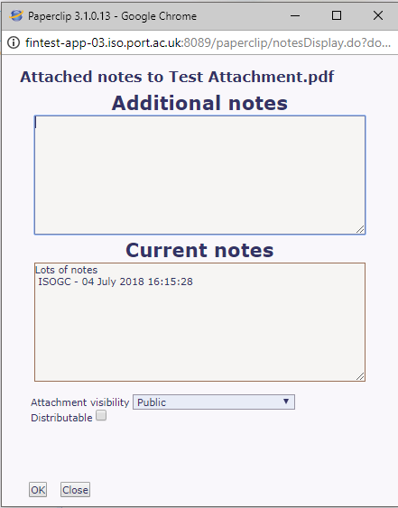

Related Document
Lists any attachments in the system where there is a link to the record you are viewing. This can be supplier transactions for the order being viewed or goods receipts etc
Figure 7
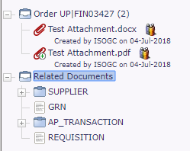

Block 5
Second Floor
St. Andrew’s Court
St. Michael’s Road
Portsmouth
PO1 2PR

