cedesk@port. ac.uk

IT Training
Information Services

servicedesk@port.ac.uk
Version 5
June 2018

Invoice Logging

Table of Contents
Introduction / Overview 1
Overview 1
Goods Orders / Service Orders 2
Invoice and Purchase Order match 2
Invoice and Purchase Order do not match 2
Invoice Value/Quantity more than Goods Receipt Note (GRN) 2
Diary List 2
Notifications 3
Clearing Notifications 3
Standard Quantity Mismatch 3
Process to clear from worklist 4
Standard Value Mismatch 4
Process to clear from worklist 5
Standard Held Inv due to Price Mismatch 5
Process to clear from worklist 6
Credit Notes 6
Multi Line Orders 6
Process to clear Multi Line Orders 6
Invoice Logged 7
Weekly reports 8
Quantity/Value mismatch 8
Price Mismatch 8
Invoice Logged 9
Purchase Order 9
Points to Ponder 9
Insufficient goods receipts 9
Manual Goods Receipts 10
Re authorisation of Orders 10
Value Orders 10
Quantity Orders 10
Price Mismatches 10
Foreign Payments 10
Transferring diary worklist / e-mails 10
Carriage Delivery 10
Copy Orders 10

Introduction / Overview
As part of a University wide review of processes and procedures, the Finance Department is reviewing the procedure for the payment of invoices. Guidelines have been issued by the Government for organisations to pay their suppliers more efficiently.
This manual, documents the processes required for Payment of Invoices to Suppliers.

Overview
Departments must ensure that the correct staff authorise orders within the system. This is the only authorisation required.
All Supplier invoices will now be received centrally by the Payments Section in Finance. Each invoice will require an order number annotated by the Supplier.
If an invoice is received without an order number, the invoice will be logged and the Department placing the order will need to allocate an order number to the invoice.
All documentation, e.g. invoices and delivery notes, must have an order number so the relevant goods receipts can be entered against the correct order on the system.
An error message:
“Session 1 – Error: PM109: Received Value is Greater than the Maximum allowed by Controls”
This will occur if a goods receipt is entered on to the system which is the lower over £10 or 10% of the value of the order. Users will have to revise the order and get it reauthorised.

Goods Orders / Service Orders

Invoice and Purchase Order match
When placing a goods or service order, a Supplier must be given an order number.
All order lines must be put on for two decimal places when inputting an order.
All invoices should be sent by the Supplier directly to the Finance Department (Payments Section). The invoice will be entered onto e5 and matched to the order.
If all the quantities/prices agree, the system will match the invoice to the goods receipts. The order status will update to either, Complete or Await Delivery, on the Purchase Order.

Invoice and Purchase Order do not match

Invoice Value/Quantity more than Goods Receipt Note (GRN)
If the invoice value or quantity is more than the GRN, the invoices will be logged by the Payments Section. The invoice and GRN, if one exists, will be given a status of ‘HELD’. If there is no GRN, only the invoice will get a status of ‘HELD’.
The user will receive an email and a Diary List message for each type of invoice/order query.

Diary List
The Diary List holds notifications for the user to action.
Application menu: Application → Diary →Worklist → Diary List
Figure 1
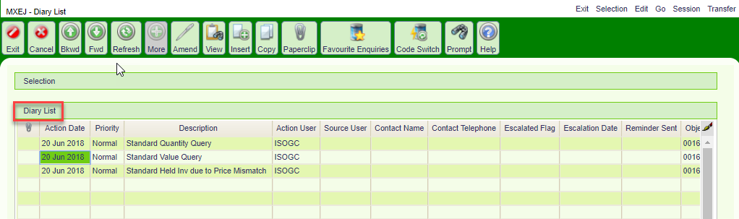

Notifications
These are the types of notifications you will receive for GRN or price queries.
Query | Description
Standard Quantity | QUANTITY MISMATCH: An Invoice/Credit Note has been received for one of your purchases. There are either no goods receipts or insufficient receipts to release it for payment
Standard Value | VALUE MISMATCH: An Invoice/Credit Note has been received for one of your purchases. There are either no value receipts or insufficient receipts to release it for payment.
Standard Held Inv due to Price Mismatch | An Invoice/Credit Note has been held due to a price mismatch. Please log into e5 and accept the invoice if it is correct. If the invoice price is incorrect please contact the supplier to arrange a credit note.

Clearing Notifications

Standard Quantity Mismatch
The user will receive a Quantity Mismatch email.
Figure 2
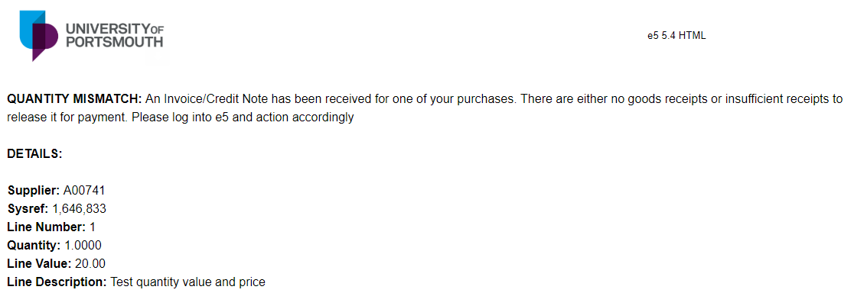

Process to clear from worklist
Diary List Double click on the line description to move to the Clearance List
Clearance List Double click on the Clearance List to move to the ‘Quantity Clearance Edit’ window
Select to view the invoice. The invoice will be available to view three hours after being entered by Payments
Select to populate the ‘Agreed Quantity’ field with the invoiced quantity
Select to populate the ‘Agreed Quantity’ field with the received quantity
Select to update and clear the query

Figure 3
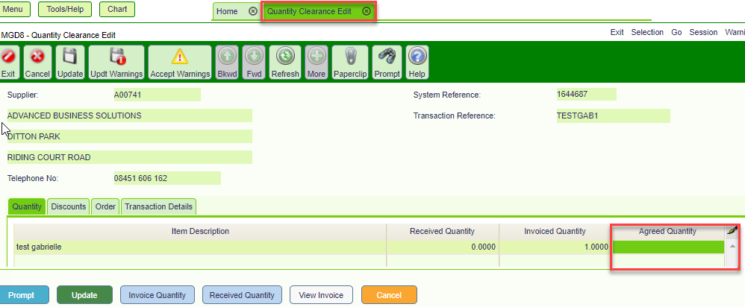
When updated the Diary List message will be removed automatically.

Standard Value Mismatch
The user will receive a Value Mismatch email.
Figure 4
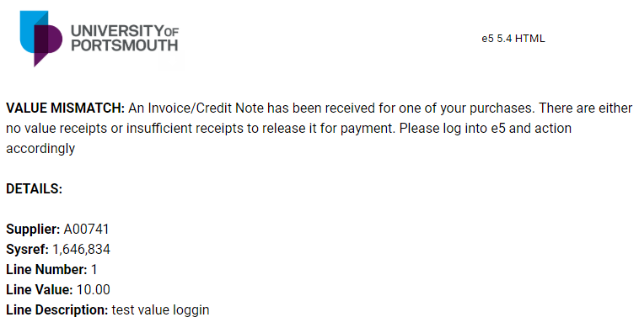

Process to clear from worklist
Diary List Double click on the line description to move to the Clearance List
Clearance List Double click on the Clearance List to move to the ‘Value Clearance Edit’ window
Select to view the invoice. The invoice will be available to view three hours after being entered by payments
Select to populate the ‘Agreed Value’ field with the invoiced value
Select to populate the ‘Agreed Value’ field with the received value
Select to update and clear the query
Figure 5
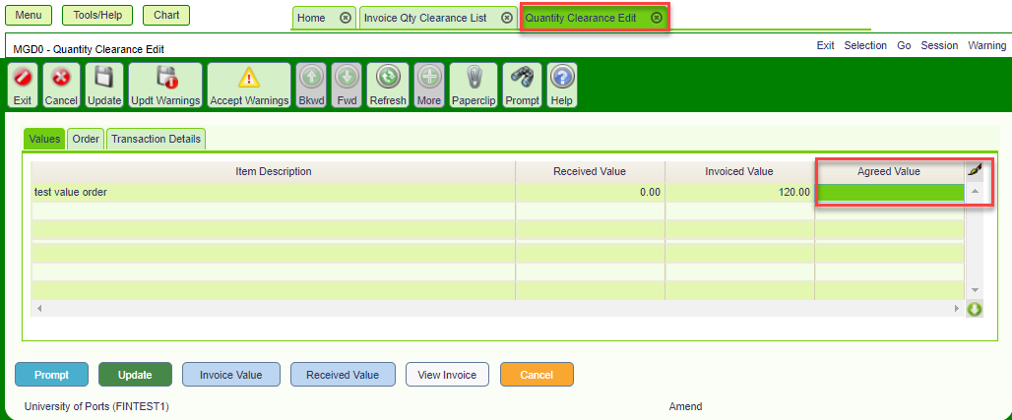
When updated the Diary List message will be removed automatically.

Standard Held Inv due to Price Mismatch
The user will receive a Price Mismatch email.
Figure 6
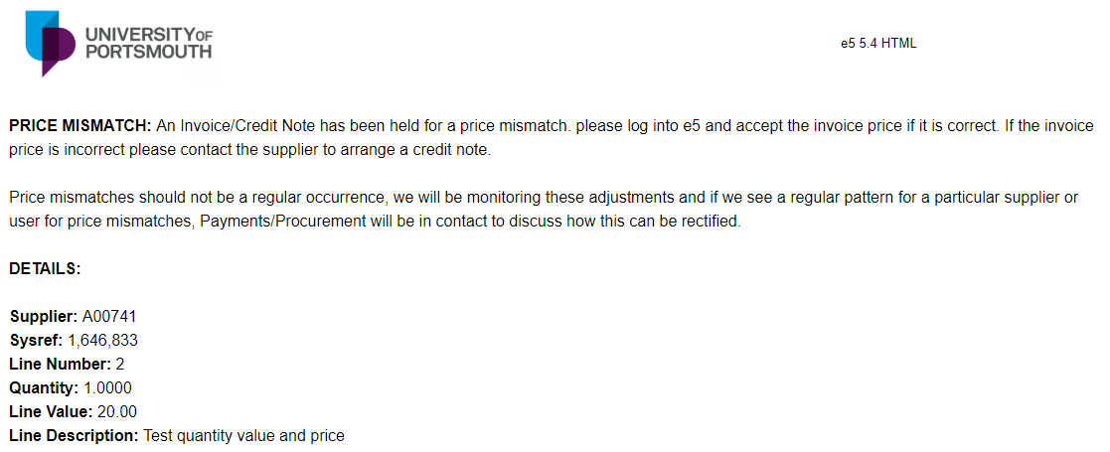

Process to clear from worklist
Diary List Double click on the line description to move to the Clearance List
Clearance List Double click on the Clearance List to move to the ‘Price Clearance Edit’ window
Select to view the invoice. There will be a time delay of up to three hours.
Select to populate the ‘Agreed Price’ field with the invoiced Price
Select to populate the ‘Agreed Price’ field with the order price
Select to update and clear the query

When updated the Diary List message will be removed automatically. The email will remain in Gmail until it is removed.

Credit Notes
Credit notes will be entered by Payments in the same way as invoices. Users will receive a notification by email. Credit Notes cannot be cleared using the Invoice Clearance Screens. Either a return or value return will need to be entered manually by the user to clear the HELD Credit Note. The overnight schedule will process these.
Figure 7
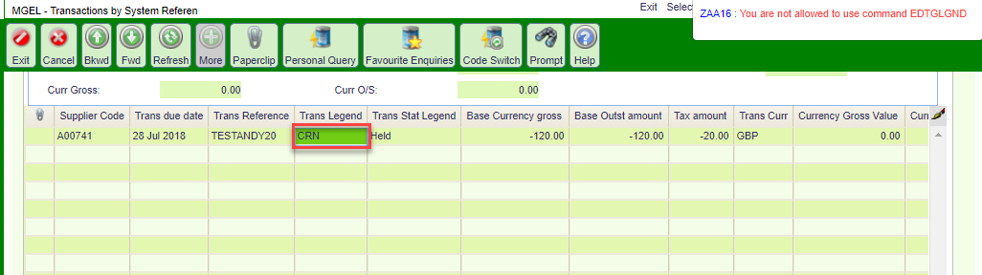

Multi Line Orders
The system will create a Diary List message and email for each line that is held on an order. Users can update multiple lines from the ‘Clearance List’ and update in bulk.
Multiple line orders can relate to Quantity, Value or a Price Mismatch. The example process below is for a ‘Multi Line Quantity Mismatch’

Process to clear Multi Line Orders
Diary List Double click on the line description to move to the Clearance List
Clearance List Double click on the Clearance List to move to the ‘Clearance Edit’ window
Agreed Quantity Click and drag to select all lines. See Figure 8 below
Select to populate all the ‘Agreed Quantity’ fields with the invoiced quantity. See figure 9 below
Select to populate all the ‘Received Quantity’ fields with the received quantity
Select to update and clear the query

Figure 8
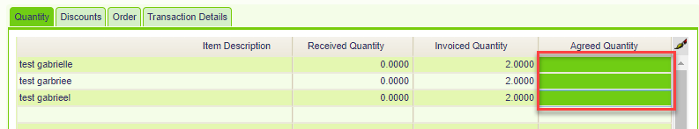

Figure 9
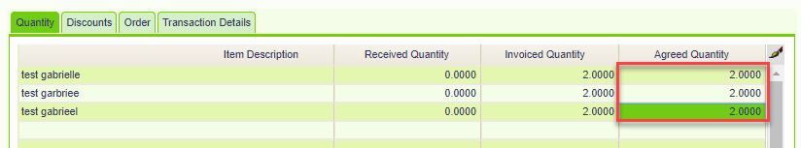

Invoice Logged
With the new process your invoice logged messages will reduce. The reasons you will receive an Invoice Logged Diary message and email are:
- The order needs to be authorised
- The order number does not exist
- The order is incomplete and needs updating

Figure 10
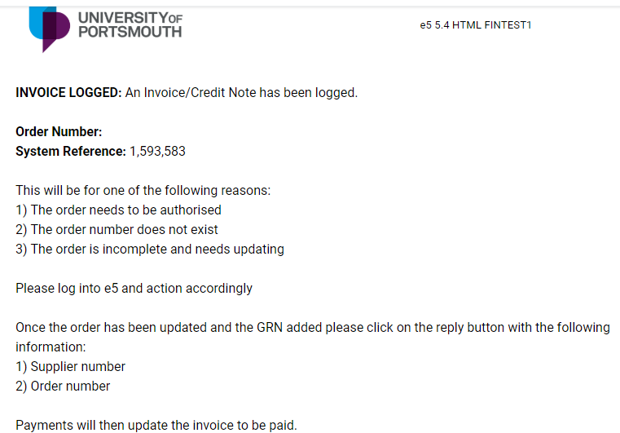
Follow the instructions in the email.

Weekly reports
Users will receive up to three weekly reports, on a Wednesday, of all outstanding invoice/order mismatches. These will be attached to an email.
Users still need to action notifications.

Quantity/Value mismatch
Quantity/Value mismatch email and report

Figure 11
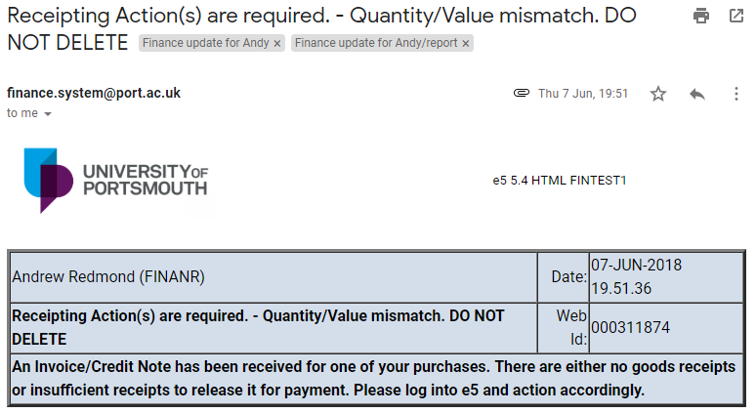
Figure 12
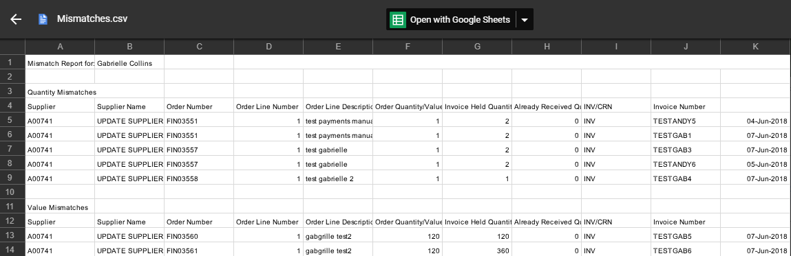

Price Mismatch
Price mismatch email and report
Figure 13
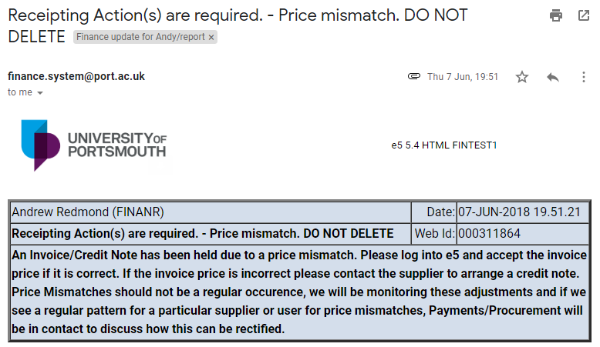
Figure 14
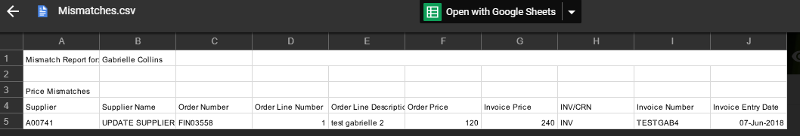

Invoice Logged
Invoice logged email and report.
Figure 15
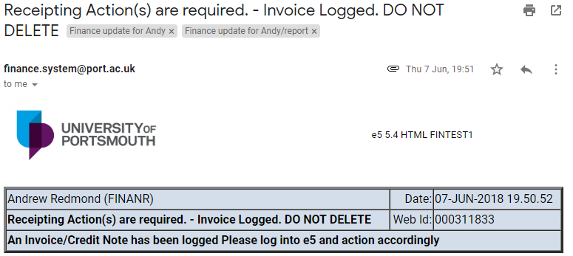
Figure 16
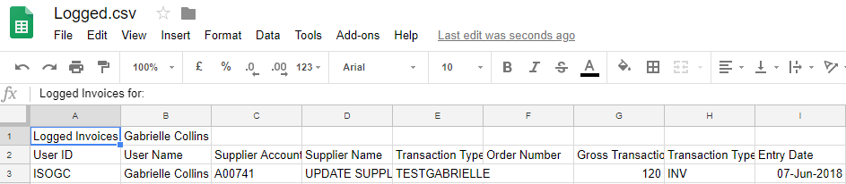

Points to Ponder

Purchase Order
There are a number of tabs on the Clearance List, select the Order tab to see a copy of the order.

Insufficient goods receipts
When an invoice is held because there are insufficient Goods Receipts the GRN will have a status of HELD as shown in the figure below. When the extra GRN has been processed the existing GRN will then be updated accordingly.
Figure 17
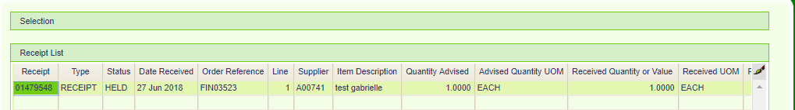

Manual Goods Receipts
The most efficient way to resolve queries is to use the Clearance List from the Diary List for each type of query. Set out above.
Users can enter the Goods Receipts manually. Please be aware that these will be managed by overnight processes so will not update immediately. The Diary List message will be removed after the overnight run.
If you choose this method the GRN must be entered to the correct line number.

Re-authorisation of Orders

Value Orders
If the Invoice value exceeds the order value by 10% or £10 (whichever is the greater), then the order will need to be revised to the invoice value and re authorised. Use the Dairy List to accept the Invoice value or the GRN can be added manually.

Quantity Orders
Quantity orders should be revised if there is a difference of either 20% or £50 (whichever is the lower) between the order price and the invoice price.
Finance will regularly monitor these adjustments and will review consistent differences.

Price Mismatches,
If an order needs revising because of a price mismatch, Payments will need to cancel the invoice before a user can amend the price on the order.

Foreign Payments
Foreign currency payments cannot be processed in this way; you will still need to fill out a FIN4 form in order for these invoices to be paid.

Transferring diary worklist / e-mails
If a user is absent, e.g. on annual leave, contact the Finance Systems Team via email so that a transfer diary event can be set up. All Business Events will be transferred to the named user specified in the e-mail during the period of the absence.

Carriage Delivery
Delivery charges that appear on the invoice but not on the order will be automatically accepted by the Payments Team up the value of £25. This will be charged to the same Cost Centre as the majority of the order.

Copy Orders
If an order is copied, notifications will be sent to the creator of the original order.

Block 5
Second Floor
St. Andrew’s Court
St. Michael’s Road
Portsmouth
PO1 2PR

