IT Training (in collaboration with Finance)

COA e52
Year End Housekeeping
CDR10

Version 2
January 2011
ithelp.port.ac.uk/ittraining
Twitter: @ISUOP
www.port.ac.uk/finance

Introduction 1
Overview of Housekeeping 1
Housekeeping Schedule 1
Identifying Orders 2
Order Enquiry / Copy Screen Enquiries 2
Location 2
Primary Search 3
Secondary Search 3
Extended Search 3
Navigation Options to access the Order Line List Enquiry screen 3
Order Summary Screen 4
Location 4
Point to Ponder 4
GRN statuses 4
Navigation Options to access the Order Summary Enquiry screen 5
Enquiry- Order Line List Screen 5
Navigation Options to access the Order Line List Enquiry screen 5
Overview - Secure Shell SQL Reports 6
Logging on 6
Points to Ponder 7
Host Identification 7
Process to Run a Report 7
Points to Ponder 7
Case and format requirements 7
Correcting mistakes 8
Transferring a Report to the Local Network 8
Process to Transfer a Report 8
Point to Ponder 8
Housekeeping of reports 8
Exporting a report to a local directory 9
Process to Export a Report to a Local Directory 9
Sorting data in Excel 10
Process to sort data in Excel 10
Reviewing an order in COA 10
Location 10
Points to Ponder 10
Completed Order 10
COMC’s 10
Orders Annotated on the G1 Balance Report 11

Introduction

Overview of Housekeeping
Information is required for the statutory Financial Accounts which are published and used by external stakeholders to the University.

At Year End, the Finance Department needs to recognise any amounts outstanding to Suppliers, for goods and services received by 31 July.

To verify these amounts, the Financial Accounts section will produce a report of any outstanding amounts, called G1 Balances. These will be sent electronically in mid April, June and July to budget holders and Finance Officers, which in turn are disseminated throughout the departments to check.

The report will detail a single figure for each Nominal Code and Cost Centre Code with an outstanding balance. The report does not provide information on the orders which make up these balances and, therefore, they must be checked by the departments following the processes described in this manual.

Housekeeping Schedule
From April through to July, Finance will commence monitoring the G1 balances. The G1 Balance Report will be sent electronically to the Faculties and Departments
To avoid lengthy G1 Balance Reports, it is recommended that Housekeeping is undertaken at the end of each quarter, e.g.
Quarter | Dates
1st | 01 August to 31 October
2nd | 01 November to 31 January
3rd | 01 February to 30 April
4th | 01 May to 31 July

Individual orders that make up the balance for the Nominal Code and Cost Centre Code will need to be identified. See Identifying Orders, page 2.
The processes and the skills required will already have been gained whilst undertaking other tasks within COA, and have been delivered by the main COA Modules and documented accordingly.
This manual should be used in conjunction with all existing COA Module manuals which can be found on the following web pages at www.is.port.ac.uk/ittraining
The Actions Table will help identify the work to be undertaken, and reference to the appropriate Module Manual. See the Actions Table, page 11

Identifying Orders
The G1 balances are made up of individual orders for the Nominal and Cost Centre Code. Each individual order will need to be identified and reviewed to enable the appropriate action to be undertaken.
A combination of the Order Enquiry / Copy screen and the SSHELL reports will enable this review, e.g.

Order Enquiry / Copy Screen via Enquiry Selection Window using Primary and Secondary search
Order Enquiry / Copy Screen via Extended Selection Window
Enquiry Order Summary Screen giving an overview of the order

Order Enquiry / Copy Screen Enquiries
The Order List screen provides basic information relating to the order, e.g. the supplier, value and status.
This screen is the starting point for all order enquiries on COA e52. Once the order / range of orders have been identified, all other enquiry screens can be accessed from this screen.

Location
End User Main Menu Order Management Order Enquiry/Copy

Figure 1 – Example of Order List screen
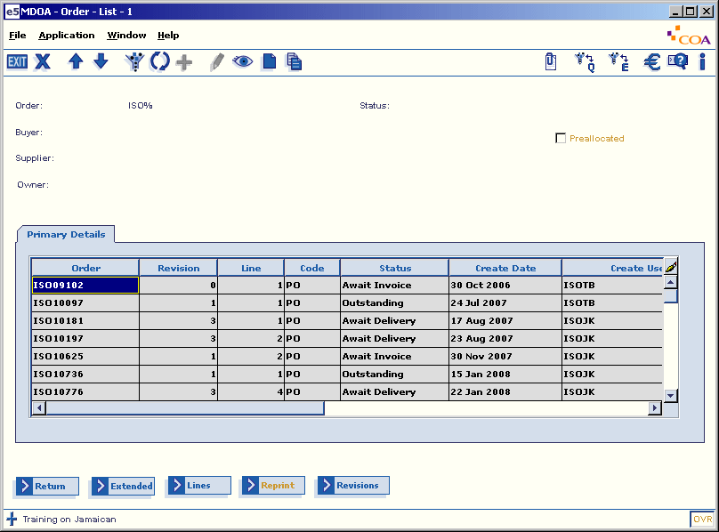

Primary Search
When identifying orders using the Order List selection window, only one of the primary selection fields can be used, i.e.:
Order number | Order code
Location | Supplier
Buyer | Owner
Preallocated

Secondary Search
Additional parameters can be entered using one of the primary selection fields, plus one of the following fields:
Order number | Order code
Buyer | Location
Include Preallocated

Extended Search
The extended selection window will allow the user to select additional parameters when enquiring on an order, e.g.:
Order number | Value
Date Created | Date Printed
Invoice Location | Create User
Currency | Status indicators

Navigation Options to access the Order Line List Enquiry screen
Order List screen Right click Display Lines
Order List screen Menu bar Application Display Lines
Order List screen [Lines]

Order Summary Screen
The Order Summary screen displays an overview of the order.
In addition to the overall value of the order, receipts and invoices, this screen provides details for individual order lines, e.g. order line value, receipts value and actual value invoiced.

Location
End User Main Menu Order Management Order Enquiry/CopyLinesSummary

Figure 2
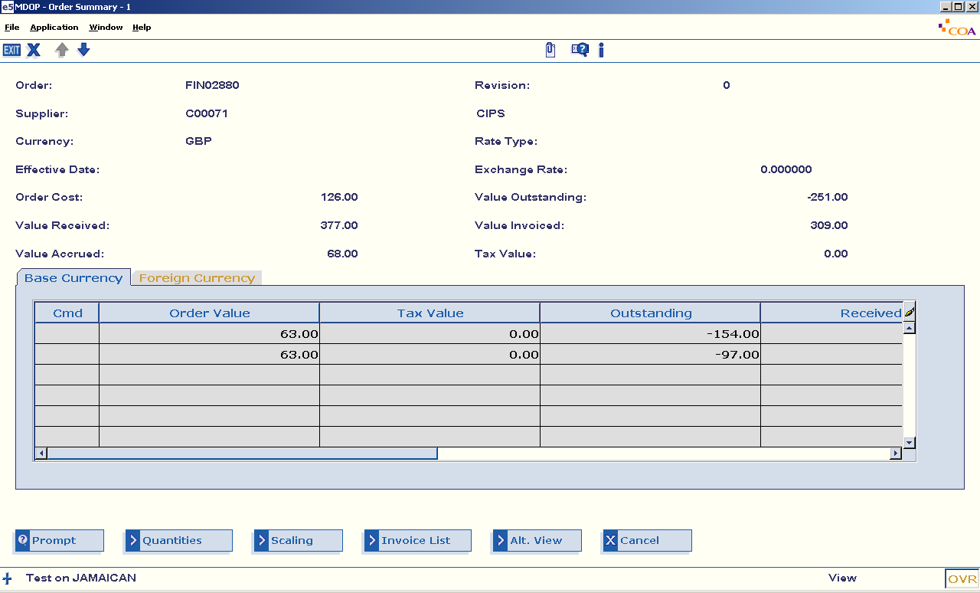

The summary screen gives you a clear indication on the summary of the order.

Point to Ponder

GRN statuses
Status codes give an indication of the stage an order has reached in the purchase order cycle, see CDR04 Revisions manual for further information.
The GRN status codes relate specifically to the status of the associated invoice, e.g.
GRN Status | Explanation | Related Order Line Status
Complete | Indicates that an invoice line has been matched to the goods receipt | Complete
Outstanding | Indicates that no invoice has been matched to the goods receipt | Await Invoice
Held  Matched | Indicates that the goods receipt is held because of a mis-match in price  Indicates that the goods receipt is more than the invoice being paid | Await Invoice/Await Delivery  Await Invoice/await Delivery

Navigation Options to access the Order Summary Enquiry screen
Order List screen Right click Display Summary
Order List screen Menu bar Application Display Summary
Order List screen [Summary]

Enquiry- Order Line List Screen
In view mode, the Purchase Order Enter/Revise screen allows the order lines to be viewed exactly as they were entered onto the system. This screen can be used to enquire on an order prior to any revisions being recorded.

Figure 3
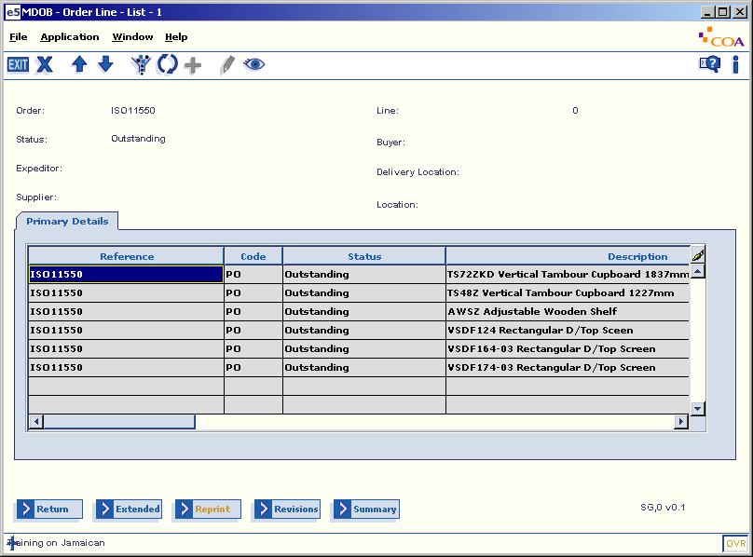

Navigation Options to access the Order Line List Enquiry screen
Order List screen Right click Display Lines
Order List screen Menu bar Application Display Lines
Order List screen [Lines]

Overview - Secure Shell SQL Reports
The SQL reports allow a variety of reports to be run which extract data from COA e52 Financials and display the data either as a printed report or in a format which can be imported into Excel or Word.
They are accessed using the Internet tool ‘SSH - Secure Shell’ which can be accessed through the Start Button / Corporate systems /Finance / SSH Shell (Jamaican).

Logging on

Figure 4
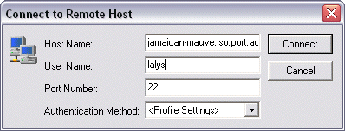

- Enter Host Name | Enter jamaican-mauve.iso.port.ac.uk in the ‘Host Name’ field
- Enter User Name | Enter the User ID in the ‘User Name’ field  The username is the university network login and is case sensitive
- [Connect]
- Enter password | Enter the password in the pop-up window  The password is case sensitive
- [OK] | The numerical list of reports will be displayed as shown in  Figure 5

Figure 5

Points to Ponder

Host Identification
After using the ‘SSH – Secure Shell’ for the first time, the system will prompt for the new host key to be saved to the local database. Use the [Yes] button.

Figure 6
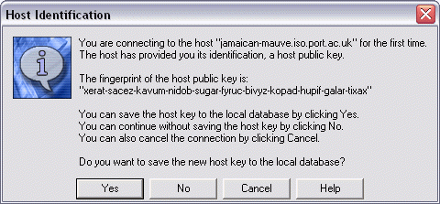

Process to Run a Report
- Select report | Enter the reference number of required report and use <Enter>
- Run report | Type ‘71’ and use <Enter> to run the sql report
- Enter requesting  - parameters | The parameters are case and format sensitive.  The requesting parameters for a selection of available reports is detailed in the Example Reports section  See Points to ponder
- Use data | The data displayed can be either:  highlighted and copied from the Secure Shell window and pasted into a word processor  or  saved as a file which can be opened in Excel (see Transferring a Report to the Local Network on page 8)

Points to Ponder

Case and format requirements
Parameters must be entered in the correct format in order for the reports to work, e.g.
all codes must be entered in upper case, e.g. UP, 4303A
all dates must be entered in the format DD-MM-YYYY, e.g. 20-JUNE-2010

Correcting mistakes
In order to correct a typographical error use <Shift> + <Backspace> to delete a previous character.
No facility exists for correcting a parameter which has already been entered. In such cases, the report will need to be re-run with the correct criteria.

Transferring a Report to the Local Network
Once run, the data from a report is saved to a file on the COA e52 server. This file can be transferred to an appropriate location on the user’s pc or local network from where it can be opened and manipulated using Excel.

Process to Transfer a Report
- Run report
 | To open the Secure File Transfer window
- Select destination | Use the ‘Local Name’ window to navigate to the destination folder for the data file
- Transfer | Identify the report file and drag it from the ‘Remote Name’ window to the chosen destination folder, see Figure 7  It is now accessible on the local network and can be opened with the appropriate application, e.g. Excel

Figure 7
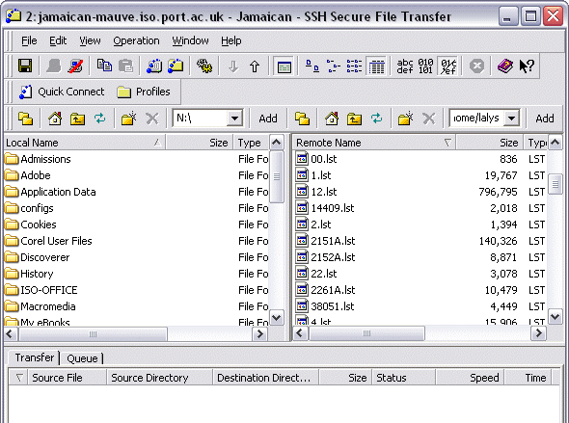

Point to Ponder

Housekeeping of reports
When only one report has been run, the application can be exited (File Exit). To reduce storage of unnecessary data, delete the file from the home directory.

Exporting a report to a local directory
Once run, the data from a report will need to be converted into Excel where it can be opened and the data manipulated.

Figure 8
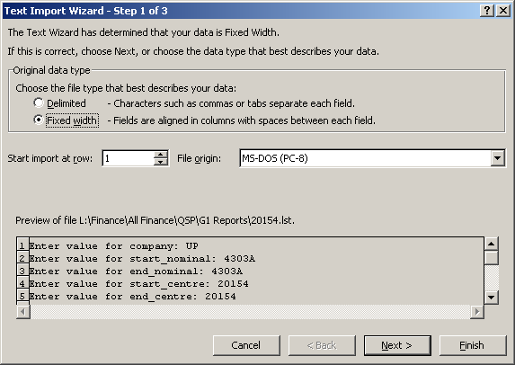

Process to Export a Report to a Local Directory
- Open Excel
- Select directory |  |  | Identify the destination folder that the report was transferred to
- Select report: |  | Which will activate the ‘Text Import Wizard’, see Figure 8 above
 | - Select ‘Import Row 11’
 | - [Next]
 | - Delete ‘Create Break Lines’ | To ensure a header is visible for each column
 | - [Next]
 | - [Finish]

Sorting data in Excel
To be able to identify the order and the balance in COA, the data will need to be sorted using Excel.

Process to sort data in Excel
- Delete row A2 |  |  | To exclude dashes in the data
- Select row A1 |  |  | Data Sort Sort by order
- Identify any COMC |  |  | If appropriate, copy Column C to Column G.  Repeat the Data Sort again.
- Data Subtotal |  |  | Subtotal Sort by order
- Select row 2 |  |  | Information to be removed, only balance and order number to remain
- Data in column M: |  | Right click and format cells
 | - Select number | To flag 1000 separator

Reviewing an order in COA
The order will need to be viewed in COA to ascertain why there is a balance.

Location
End User Main Menu Order Management Order Enquiry/Copy

If the order has a status code of ‘Complete’, contact the COA System Finance Team with the following information:
Nominal code
Cost Centre code
Order Number – highlighting that it is a G1
Amount to clear
Credit or Debit

Points to Ponder

Completed Order
The order has to have a status code of ‘Complete’ before the information is sent to the COA System Finance Team.

COMC’s
Commitment Clears (COMC’s) are one sided journals that the COA System Finance Team have entered to clear balances that have not cleared once an order has been completed.

Orders Annotated on the G1 Balance Report
The orders that make up a G1 balance and what action may be required:
Status of Order | Current Position | Action | Manual
Outstanding | All now received | Enter goods receipt | CDR03
 | Partially received | Enter goods receipt against relevant order line/s | CDR03
 | None received | None
 | None received, and no longer required | Cancel order | CDR04
 | None received, and supplier is no longer available | Cancel order  If order still required, re-order from another supplier | CDR04
Await Delivery | Remainder has arrived | Enter goods receipt | CDR03
 | Partially received | Enter goods receipt against relevant order line/s | CDR03
 | Outstanding items no longer available  Items already received to be returned to the Supplier | Cancel goods receipt and cancel order  If appropriate request a credit note | CDR04
 | Outstanding items no longer available/required  Items already received to be kept | Complete the order lines received and leave the remaining lines | CDR04
 | Goods receipt exists, but paid against only one line in error (by payment assistant) | Subsequent lines to be cancelled by departments | CDR04
 | Goods have been received, but the goods receipt does not match the invoice. The amount paid has left an outstanding balance | Enter a return for the outstanding balance | CDR03
Await Invoice |  | Awaiting payment by Finance

Halpern House
Hampshire Terrace
Portsmouth
PO1 2QF

