e5
Customer Invoicing
CDR09

Version 6
December 2017
myport.ac.uk
Twitter: @ISUOP
www.port.ac.uk/finance

Introduction 1
Customer Account Numbers 1
Customer Credit Rating 1
Low Value Invoices 1
Credit Notes 1
Recording Sales Invoices / Credit Notes 2
Sales Invoices 2
Credit Notes 2
Overview of Processes 2
Step 1 - Location 3
Field Chart 3
Step 1 - Process to Enter a Sales Invoice 4
Step 1 - Process to Enter a Credit Note 5
Points to Ponder 5
Finding a customer’s account number and billing address 5
Sales Invoice / Credit Note Entry Macro Buttons 6
Step 2 - Header Text 7
Field Chart 7
Step 2 - Process to Add Header Text 8
SI Document Text Edit Macro Buttons 8
Step 3 - Line Text 9
Field Chart 9
Step 3 - Process to Add Line Text 10
SI Document Line Text Edit Macro Buttons 10
Enquiry - Customer Credit Limit 11
Location 11
Field Chart 12
Credit Limit List Macro Buttons 13
Enquiry - Customer Account Details 14
Location 14
Field Chart 15
Point to Ponder 16
Transactions via Customer Macro Buttons 16
Enquiry - Sales Invoice / Credit Note 17
Location 17
Process to identify a sales invoice / credit note 17
1

Introduction
Customer invoices (also referred to as sales invoices) are raised on e5 whenever chargeable goods or services are provided to an external body. Customer invoices are entered onto e5 so that the value of the transaction can be credited to the department’s budget and the Credit Control department can manage the process of collecting payment.

Customer Account Numbers
All University / UPEL customers have unique account numbers against which their invoices are raised. The University categorises all its debts into a number of ledgers and each customer account number is automatically associated with the appropriate ledger, e.g.
a member of staff with a nursery debt will have an account associated to the ’07 – Nursery’ ledger.

Customer Credit Rating
The Credit Control Team will check the credit rating for all new customers prior to setting up their account on e5. This needs to be done before any goods/services are provided to a customer.
To obtain a credit rating for a new customer, submit a request to the income team using the form on the finance intranet here:
http://www.port.ac.uk/intranet/finance/usefuldocumentsandguides/forms/creditcheck
Credit Control will assign a credit limit to each account which represents the maximum level of outstanding debt this customer can incur.

Low Value Invoices
Sales invoices should only be raised for goods / services totaling £50 or more. Where the total is less than this, payment should be received before the goods / services are provided. Due to the costs incurred by the University in processing invoices and chasing debts, any exception to this should be agreed in advance with Credit Control.
In many cases low value items can be sold via the university online store. Please contact onlinestore@port.ac.uk for more information.

Credit Notes
Credit notes are raised to adjust or cancel an invoice and are processed on E5 using the same screen as sales invoices. Credit notes require authorisation by Vicky Bruce or Liz Bartle and as such they must be informed when one is raised.
Once entered onto E5 invoices cannot be revised if a mistake has been made, they must be ‘cancelled out’ and then re-entered. This is achieved by raising a credit note corresponding to the original invoice before re-entering the invoice.

Recording Sales Invoices / Credit Notes

Sales Invoices
Sales Invoices are entered on E5 whenever items or services are provided, by the University, to an external body.
All sales invoices must include a full, accurate description of the goods or services being provided. This is an audit requirement.
Once a sales invoice has been entered on E5 the invoice is emailed directly to the customer’s default billing address or, where no email address is specified against the customer, the invoice is printed by finance and posted to them. The customer then has 30 days to pay, after which, the Income Team will begin the debt collection procedure.

Credit Notes
Credit notes are entered on E5 when a sales invoice value has been input incorrectly or if goods / services are no longer required.

Overview of Processes
There are up to three steps when entering a new sales invoice / credit note, i.e.

Step 1 | Create Sales Invoice / Credit Note | Record the basic sales invoice / credit note information, e.g. document type, prefix, ledger
Step 2 | Add Header Text | If applicable, record an annotation against the whole invoice / credit note
Step 3 | Add Line Text | If applicable, record an annotation against a specific invoice / credit line

Step 1 - Location
Customer Invoicing Create Sales Invoice / Credit Note

Figure 1
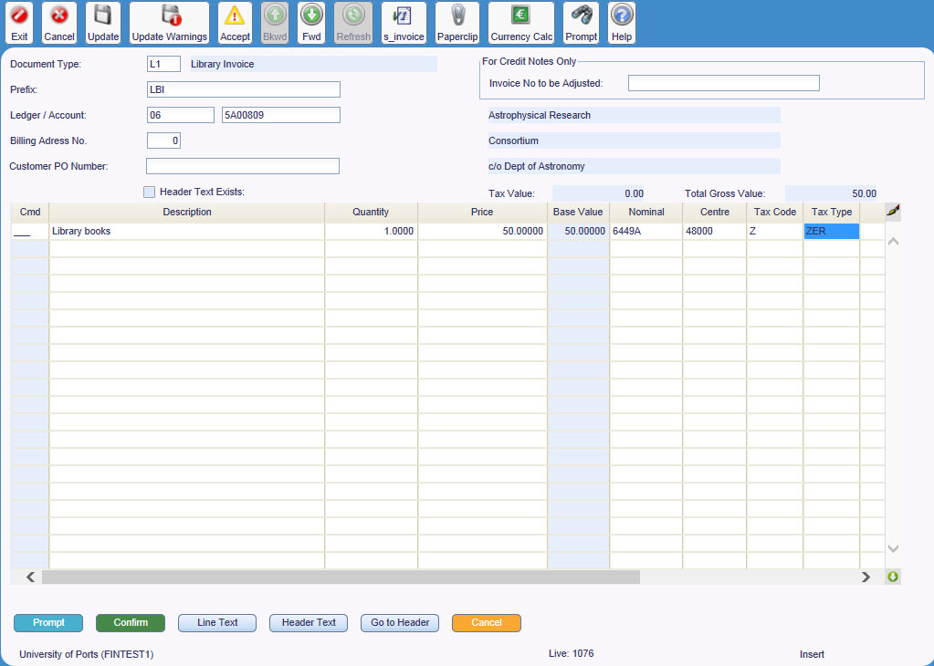

Field Chart
Field | Description
Document Type | Departmental transaction type  E.g. YI – Library invoice, YC – Library credit note, TI – Technology invoice, SI –Sundry debtor invoice
Prefix | Invoice prefixes are the characters which identify the department raising the sales invoice. The prefixes are followed by a system generated number  E.g. LBI – Library Invoice
Ledger / Account | Ledger and account number for this customer  E.g. Ledger 06 Account 5H00001 – H&S Aviation
Cmd | Lines can be deleted or copied, according to a set of rules
Description | Description of the item / service supplied
Quantity | Quantity of the item supplied or ‘1’ if a service has been supplied
Price | Cost of item / service, excluding VAT
Value | Amount of this invoice line (system calculated)
Nominal | Nominal code for this invoice line  E.g. 6449A – Miscellaneous general income
Centre | Cost centre for this invoice line  E.g. 41126 – Centre for manufacturing and industry
Tax Code / Tax Type | Code indicating the level of VAT applicable to this invoice line  E.g. STD – Standard 20.0% VAT, ZER – Zero rated
Tax Amount | Value of VAT for this invoice line
Header Details screen - accessed via [Go to Header]
Document | Departmental transaction type  E.g. YI – Library invoice, YC – Library credit note, TI – Technology invoice, SI –Sundry debtor invoice
Order Reference | Customer’s order reference number for this invoice
Transaction Date | Not used
Due Date | Not used
Tax Date | Not used
Customer Billing Address | Address number to which the invoice applies
Gross Invoice Value | Value of complete invoice including VAT
Tax Value | Value of VAT for the complete invoice

Step 1 - Process to Enter a Sales Invoice
- Complete Line Details screen |  | Complete the mandatory fields:  Document Type field  Ledger / Account (See Points to Ponder)
- Open Header Details screen |  | [Go to Header]
 | - Record data | Complete the mandatory fields:  Billing Address (See Points to Ponder)
- Open Line Details screen |  | [Go to Lines]
 | - Record data | Complete the remaining mandatory fields:  Description  Quantity  Price  Nominal  Cost Centre  Tax Code
- Confirm Invoice |  |  | [Confirm]

Step 1 - Process to Enter a Credit Note
- Complete Line Details screen |  |  | Complete the mandatory fields:  Document Type field  Ledger / Account (See Points to Ponder)
- Open Header Details screen |  |  | [Go to Header]
 |  | - Record data | Complete the mandatory fields:  Order Reference – enter the original invoice number to which this credit note relates  Billing Address (See Points to Ponder)
- Open Line Details screen |  |  | [Go to Lines]
 |  | - Record data | Complete the remaining mandatory fields:  Description  Quantity  Price  Nominal  Cost Centre  Tax Code
- Open line text screen |  |  | [Line Text]
 | - Record data |  | Use line text to record the reason for the credit.
- Confirm credit note |  |  |  | [Confirm]
- Inform Finance |  |  | For authorisation, email Vicky Bruce or Liz Bartle

Points to Ponder

Finding a customer’s account number and billing address
If a customer’s account number and ledger are not known, they can be found using the prompt facility:
- Prompt |  | Leave ‘Ledger’ field blank and prompt on ‘Account’ field  Enter first three letters of the customer’s name in ‘Short Name’ field
 | - Check billing address number | Select any field on appropriate customer’s records
 | - View | ‘Menu bar Application Address View’
 | - Exit | [Cancel] then [Return]

Any customer on E5 could potentially have more than one address listed, e.g. a large company could have different departments for whom the University provides services.
The Billing Address field will default to address ‘0’ but should be changed on the ‘Header’ screen to reflect the correct department or individual’s address.

Credit note authorisation
The document will not be authorised if a valid reason for the credit is not provided. Use header or line text to record this information.

Sales Invoice / Credit Note Entry Macro Buttons
- [Prompt] | Where available, allows prompting on a selected field
- [Confirm] | Saves the invoice / credit note
- [Line Text] | Opens the screen used to record line text (see page 9)
- [Header Text] | Opens the screen used to record header text (see page 7)
- [Cancel] | Returns to e5 Hierarchical Finance Suite Menu without creating the invoice / credit note

Step 2 - Header Text
Header text is used to annotate an Invoice. Any information entered as header text will appear above the invoice lines on the printed document.

Figure 2
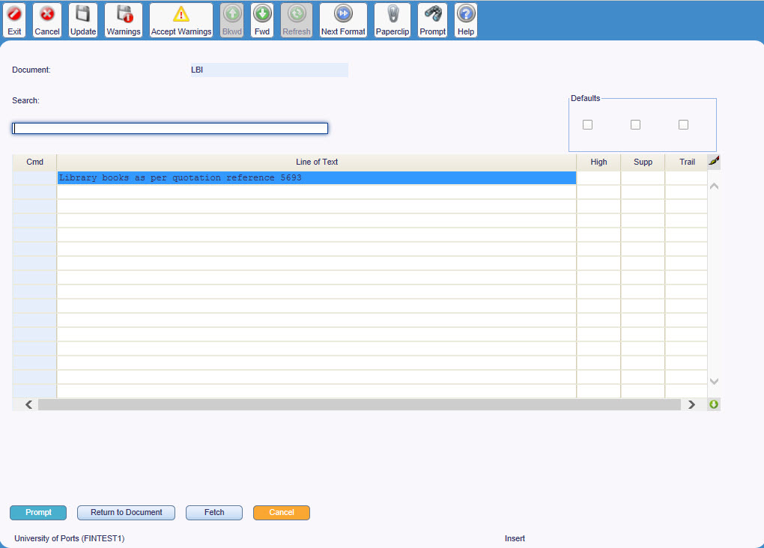

Field Chart
Field | Description
Document | Departmental transaction type  E.g. LI – Library invoice, LL – Library credit note, TI – Technology invoice, SI –Sundry debtor invoice
Search | Not used
Defaults check boxes | Not used
Cmd | Lines can be deleted or copied, according to a set of rules
Lines of Text | Free-text comments for this invoice
High | Not used
Supp | ‘Y’ indicates that this line of text will not appear on the printed copy of this invoice
Trail | Not used

Step 2 - Process to Add Header Text
- [Text] | Opens SI Document Text Edit screen
- Enter Header text | Enter free-text comments in the ‘Line of text’ field
- Return to invoice | [Document] to return to the invoice or [Confirm] to save the whole invoice

SI Document Text Edit Macro Buttons
- [Prompt] | Not used
- [Confirm] | Saves the whole invoice
- [Document] | Returns to the invoice entry screen having ‘saved’ the header text
- [Fetch] | Not used
- [Cancel] | Returns to the invoice entry screen having ‘saved’ the header text

Step 3 - Line Text
Line text is used to annotate a specific invoice line, e.g. to include additional description. Each line on an invoice can have its own line text and any information entered as line text will appear under the appropriate line on the printed document.

Figure 3
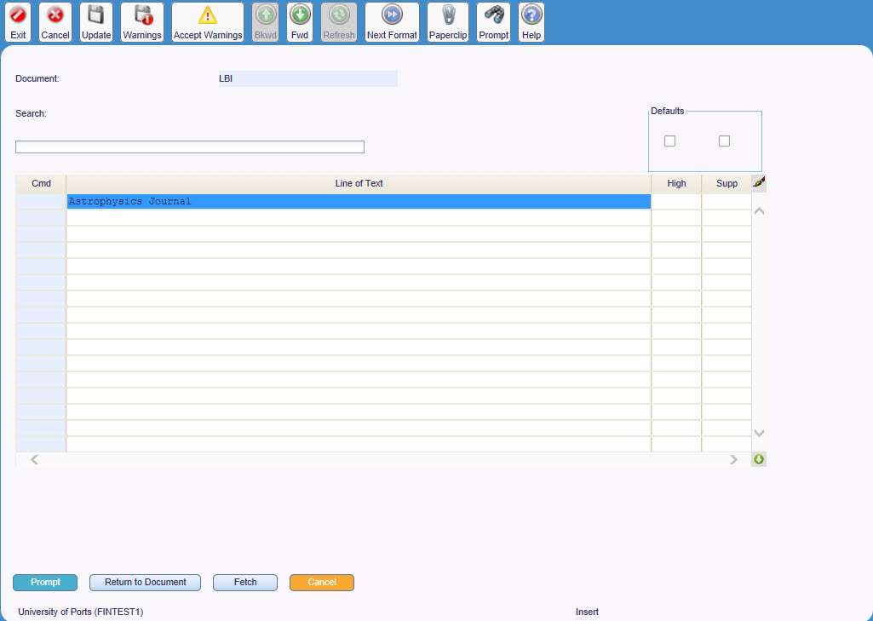

Field Chart
Field | Description
Document | Departmental transaction type  E.g. YI – Library invoice, YC – Library credit note, TI – Technology invoice, SI –Sundry debtor invoice
Search | Not used
Defaults check boxes | Not used
Cmd | Lines can be deleted or copied, according to a set of rules
Line of Text | Free-text comments for this invoice line
High | Not used
Supp | ‘Y’ indicates that this line of text will not appear on the printed copy of this invoice

Step 3 - Process to Add Line Text
- Select invoice line | Select any field on the relevant invoice line
- [Line Text] | Opens SI Document Line Text Edit screen Use [Line Text]
- Enter line text | Enter free-text comments in the ‘Line of text’ field
- Return to invoice | [Document] to return to the invoice or [Confirm] to save the whole invoice

SI Document Line Text Edit Macro Buttons
- [Prompt] | Not used
- [Confirm] | Saves the whole invoice
- [Document] | Returns to the invoice entry screen having ‘saved’ the line text
- [Fetch] | Not used
- [Cancel] | Returns to the invoice entry screen having ‘saved’ the line text

Enquiry - Customer Credit Limit
Before raising an invoice, the customer’s credit limit and current outstanding debt must always be checked.
A customer’s credit limit, and any temporary change to this limit, is displayed on the Credit Limit List screen. From this screen it is possible to access the Account Details screen which displays any outstanding debt.

Location
- Customer Invoicing View Customer Credit Limit
- Select ‘Prime’ from drop down
- [OK]

Figure 4
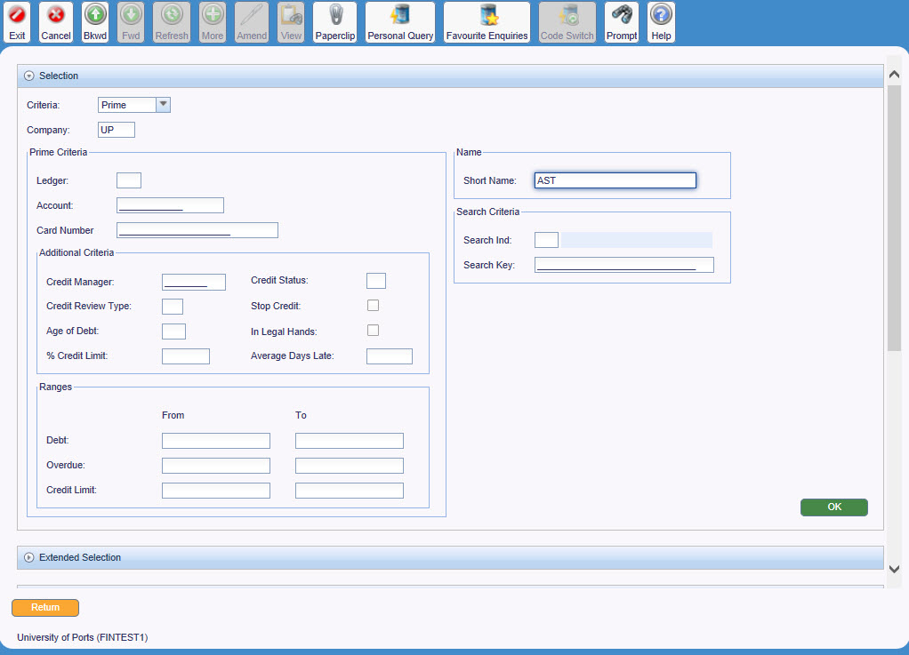

Identify the customer using the first three letters of their name in the ‘Short Name’ field in the selection window.

Figure 5
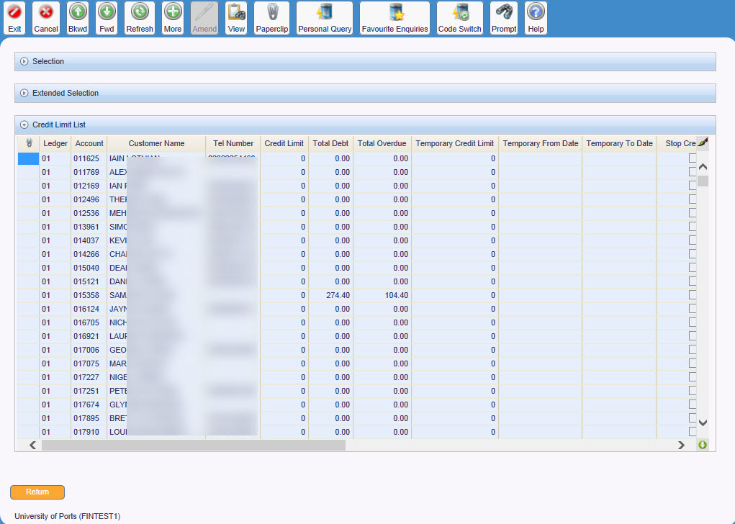

Field Chart
Field | Description
Primary Details Tab
Ledger | Ledger number for this customer  E.g. 06 – Sundry ledger
Account | Unique reference number for this customer’s account  E.g. 5H00001
Customer Name | Customer’s name  E.g. H&S Aviation
Credit Limit | Credit limit for this customer. ‘0’ indicates that no limit has been set, not that no invoices can be raised
Short Name | First three letters of the customer’s name
Temp Credit Limit | Not used
From Date | Not used
To Date | Not used
Head Office | Not used
Group Credit Limit | Not used

Credit Limit List Macro Buttons
- [Return] | Returns to e5 Hierarchical Menu
- [Extended] | Not used

Enquiry - Customer Account Details
For a new invoice to be entered, the totalled value of that invoice and the current outstanding debt must be less than the credit limit for the customer.
By default, as well as displaying the total level of outstanding debt, the Account Details screen also lists any outstanding invoices.

Location
Customer Invoicing Customer Account Enquiry Account Details

Figure 6
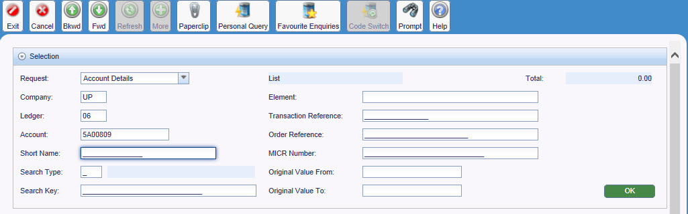

Identify the customer using the customer ledger and account number in the selection window.

Figure 7
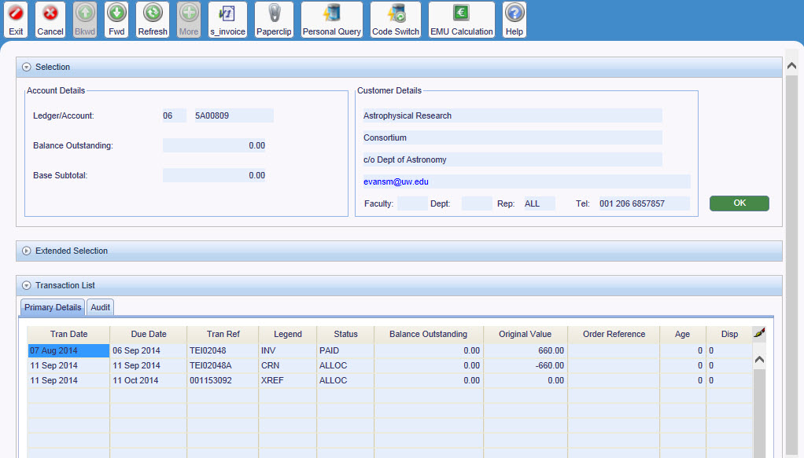

Field Chart
Field | Description
Account Details
Ledger / Account | Ledger number and unique reference number for this customer’s account  E.g Ledger 06 Account 5H00001 – H&S Aviation
Diary Count | Not used
Balance Outstanding | Current outstanding debt for this customer
Base Subtotal | Not used
Customer Details
Customer Details | Name and address for this customer
Primary Details
Tran. Date | Transaction date. Date this invoice was entered
Tran. Ref. | Invoice / credit note number  E.g. SDI04819
Lgnd | Transaction type  I.e. INV – Invoice, CRN – Credit note
Status | Code indicating whether the invoice has been printed  I.e. Outstanding – the invoice has yet to be printed,  Complete – the invoice has been printed
Original Value | Value of this invoice
Balance Outstanding | Current outstanding debt for this invoice
Age | Not used
Qry | Not used
Disp. | Not used
Order Reference / GL Tab
Order Reference | Customer’s order reference number for this invoice
Due Date | Date the invoice was due
Element | Not used
Year | Year the invoice was placed
Period | Period the invoice was placed

Lockbox Tab
None of the field on the Lockbox tab are used
Audit Tab
Update Date | Date the invoice was updated
Update Time | Time the invoice was updated
Update User | User id indicating the user who updated the invoice
Create Date | Date this invoice was entered onto E5
Create User | User id indicating the user who entered the invoice onto E5

Point to Ponder
If no outstanding debt exists, the Transactions via Customer screen will open displaying the selection window and a ‘No data found for specified selection criteria’ message.

Figure 8
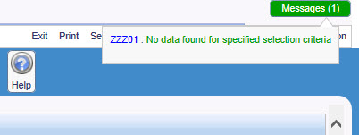

Transactions via Customer Macro Buttons
- [Search] | Not used
- [Extended] | Not used
- [Detail] | Not used
- [Aged Debt] | Age of debt
- [Cancel] | Returns to the selection box

Enquiry - Sales Invoice / Credit Note
The SI Document List screen allows an individual invoice or credit note to be identified and then displayed.

Location
Customer Invoicing Sales Invoice / Credit Note Enquiry

Process to identify a sales invoice / credit note
- Document | Identify the Sales Invoice / Credit Note number in the ‘Document’ field in the selection window.
- Right Click Edit View

Figure 9
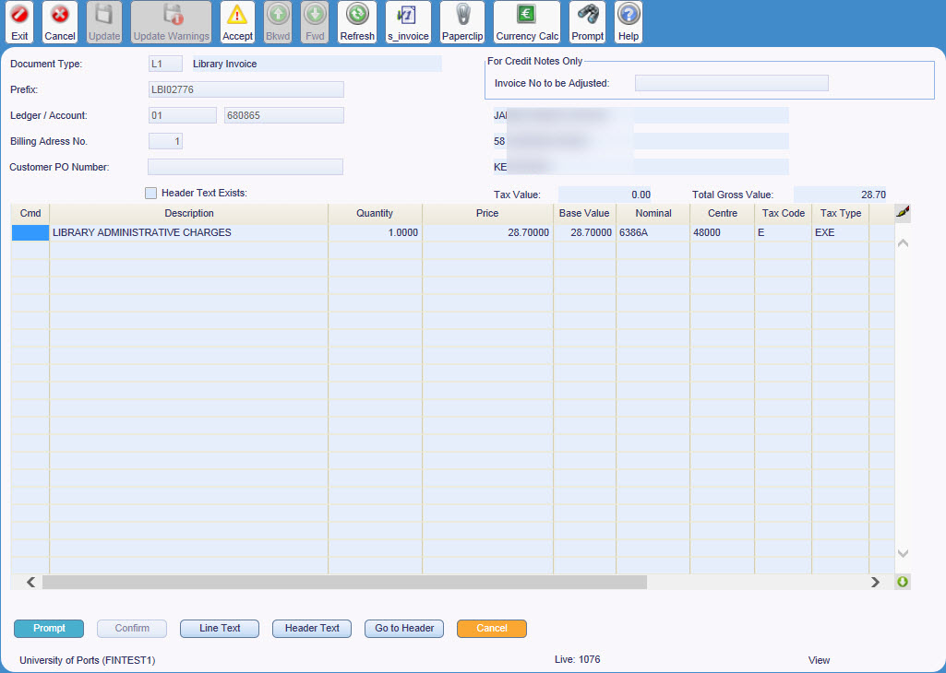
Fields as described in the Sales Invoice / Credit Note Entry field chart on page 3.
St Andrew’s Court
St Michael’s Road
Portsmouth
PO1 2PR

