

**e52**

**Budget Enquiries**

CDR08

Version 4

July 2015

[**ithelp.port.ac.uk/ittraining**](http://www.is.port.ac.uk/ittraining)

**Twitter: @ISUOP**

[**www.port.ac.uk/finance**](http://www.port.ac.uk/finance)

Introduction 1

Data Structure 2

Cost Centres, Elements and Parent Elements 2

Nominal Codes, Categories and Groups 3

Balance Classes 3

Periods 3

Ledgers 4

Layouts 4

Overview – E5 Enquiries 5

Process 5

Drilling Down 5

Displaying the selection parameters 5

Downloading Data 5

Profit & Loss Account Enquiries 6

Location 6

Selection Parameters 6

Commonly used layouts 9

Drilling Down from the Profit and Loss Enquiry screen 9

Macro Buttons 9

Account Balance Enquiries 10

Location 10

Selection Parameters 10

Points to ponder 10

Account Detail Enquiry screen 11

Field Chart 11

Commonly used layouts 12

Drilling Down from the Account Detail Enquiry screen 12

Macro Buttons 12

Account Transaction Enquiries 14

Location 14

Selection Parameters 14

Points to ponder 14

Transaction Detail List Screen 15

Field Chart 15

Display Journal Details 18

Introduction

This document covers the most common screens and processes used to make enquiries on a budget.

Data held on e5 can be viewed in two ways, i.e. through:

* enquiry screens within e5 itself
* running SQL reports

The e5 enquiry screens covered in this document allow information to be viewed relating to overall balances for an account, or relating to groups of individual transactions. This data can also be exported from E5 using the download function detailed in the CDR01 Introduction and Navigation manual.

SQL reports allow data relating to groups of transactions to be printed or exported to an Excel spreadsheet.

Data Structure

All the University’s financial transactions are ‘coded’ against a cost centre and nominal code.

A cost centre is a numeric code identifying the specific budget to which the expenditure / income is to be attributed.

A nominal code is an alphanumeric code (four digits followed by a letter) identifying the type of income / expenditure.

To assist in managing departmental budgets and to enable enquires to be performed at different levels, the University’s overall budget is broken down in several ways:

Cost Centres, Elements and Parent Elements

Nominal Codes, Categories and Groups

Cost Centres, Elements and Parent Elements

Figure 1



A cost centre is a numeric code identifying the specific budget to which the expenditure / income is to be attributed. The University sometimes refers to cost centres as ‘Project Codes’.

An element is a group of related cost centres.

A parent element is a group of related elements. Parent elements themselves can be grouped together into a further parent element. The topmost parent element will therefore encompass the entire University’s budget.

Nominal Codes, Categories and Groups

Figure 2



A nominal code is an alphanumeric code (four digits followed by a letter) identifying the type of income / expenditure.

Related nominal codes are grouped together into Categories.

Related categories are further grouped together into Groups, allowing enquiries at a yet higher level.

Balance Classes

Balance Classes are ‘data buckets’ that store financial and statistical information, including actual expenditure/income, original budgets and revised budgets, e.g.

AB – Actual Balance

C1 – Commitments

B1 – Original Budget

Periods

Periods are months in the University’s financial calendar which are referred to numerically, e.g.

Period 01 – August

Period 02 – September

Period 03 – October

Ledgers

Ledgers (sometimes referred to as ‘modules’) are used to indicate the ‘area’ of E5 Financials from which a specific transaction originates, e.g.

POP – Purchase Order Processing indicates the transaction was created by a purchase order

PL – Purchase Ledger indicates the transaction was created by Finance entering a payment

Layouts

A Layout dictates which balance classes and calculations are displayed for a particular enquiry, e.g.

‘AYTD’ displays actual expenditure for the year (balance class AB)

‘BUDG’ also displays the original budget, current forecast and the unspent budget (the original budget less any actual expenditure and commitments)

Overview – E5 Enquiries

A selection of E5 enquiry screens can be used to display account balances and transactions to assist in the management of University budgets.

Process

|  |  |  |
| --- | --- | --- |
| * Select enquiry | Select appropriate enquiry, e.g. | |
|  | Profit and Loss  Account Transactions  Account Balances |
| * Enter parameters | Information on available selection parameters is detailed in the following sections | |
| * Submit | <Return> or [OK]  The appropriate enquiry will be displayed | |

Drilling Down

A ‘drill down’ facility exists in many of the budget enquiry screens. This facility enables the user to obtain more detail on the balances or transactions that make up the particular total.

|  |  |  |
| --- | --- | --- |
| * To Drill down on an account balance: | * double click on account balance * select account balance | |
|  | * use |  |

Displaying the selection parameters

The ‘selection’ icon allows the appropriate selection window and original requesting parameters to be re-displayed. On screens where this is not present the [Extended] or [Parameters] button should be used instead.

Downloading Data

Data can be downloaded from budget enquiry screens using <Ctrl>+<D> as detailed in CDR01 Introduction and Navigation manual.

Profit & Loss Account Enquiries

The Balance Sheet/Profit and Loss Enquiry screen displays, month by month, the total expenditure/income for a given cost centre or element.

This data is displayed for each group and category in a choice of ‘layouts’ defines which additional data will also be displayed, e.g. the original budget or current expenditure as a percentage of the budget.

Location

Enduser Main Menu 🡪 Profit & Loss / Balance Sheet 🡪 Profit & Loss Account

Selection Parameters

Figure 3

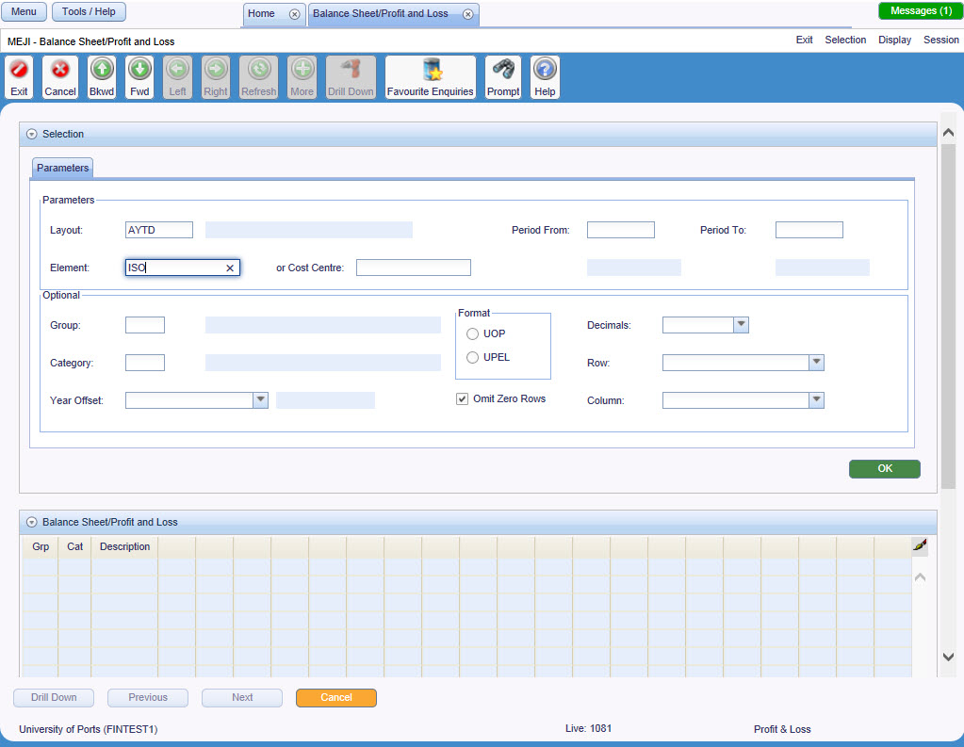

|  |  |
| --- | --- |
| Layout | Defines what columns will be displayed.  If left blank, it will default to ‘AYTD’  See page9 |
| Element / Or Cost Centre | Element or Cost Centre for which the profit and loss is to be displayed |
| Period From | Start period from which transactions will be included in the balances.  If left blank will default to current period |
| Period To | End period up to which transactions will be included in the balances.  If left blank will default to current period |
| Group | Optionally allows the profit and loss to be displayed for one specific group |
| Category | Optionally allows the profit and loss to be displayed for one specific category |
| Year Offset | Financial year to be enquired upon relative to the current financial year, e.g. ‘0’ indicates the current year, ‘-1’ indicates last financial year, ‘+1’ indicates next financial year. Up to 5 year’s history are available.  If left blank will default to the current financial year |
| Format | Indicates whether the profit & loss is to be run for University or UPEL accounts |
| Row / Column Pick Lists | Allows the screen layout to be amended  E.g. to show the groups as columns rather than rows |
| Omit Zero Rows | If checked will not display balance if zero for a particular nominal / cost centre relationship |
| Decimals Drop Down | Indicates the number of decimal places to which balances are to be displayed |

Figure 4 – example AYTD layout

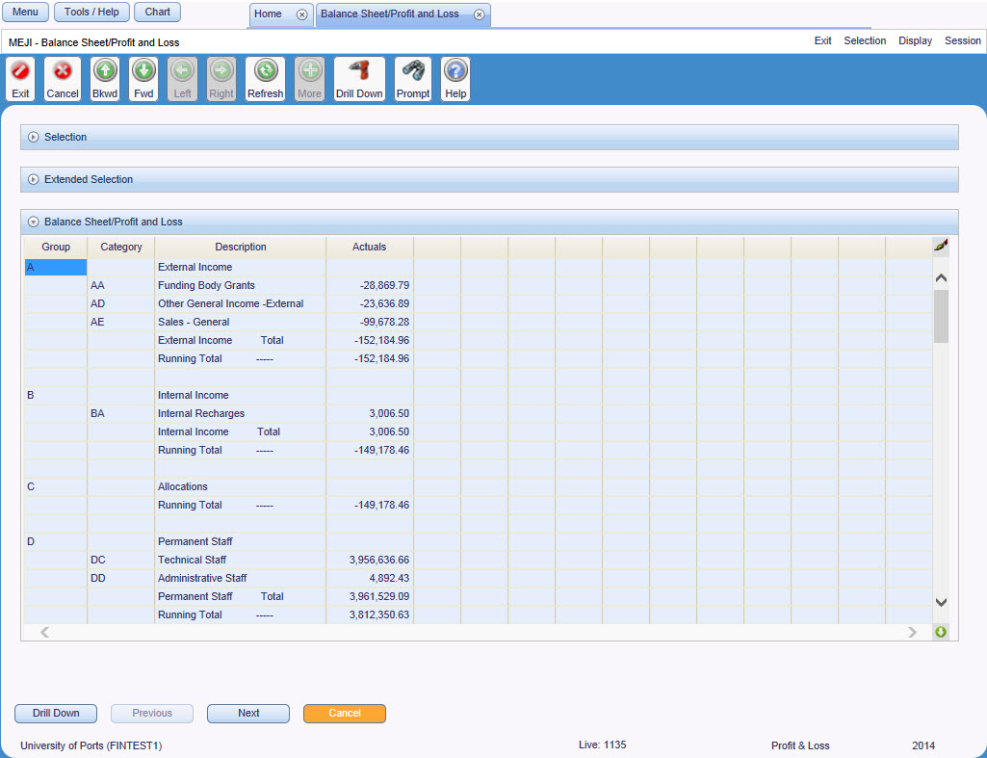

|  |  |
| --- | --- |
| The screen’s repeater block will display a combination of the following fields depending on the Layout identified in the selection window.  See Points to ponder for a breakdown of the actual fields for the most commonly used layouts. | |
| Group | Group of related categories |
| Cat | Category grouping related nominal codes |
| Description | Month name |
| Original Budget | Estimate of total expenditure/income for the year |
| Current Forecast | Current revision to the original budget |
| Variance for Year | Difference between the original budget and the current forecast |
| Actuals | Total expenditure / income |
| Committed | Total value of orders placed but not yet received |
| Goods Received | Total value of orders received but not yet paid for |
| Commits & GRNs | Combined total of the value of orders placed but not yet received and the value of orders placed but not yet received |
| Unspent Forecast | Amount of forecast not yet committed or received |
| Act % Forecast | Actuals to-date as a percentage of the current forecast |

Commonly used layouts

|  |  |
| --- | --- |
| **Layout** | **Fields Displayed** |
| AYTD | Per, Description, Actuals |
| BUDG | Per, Description, Original Budget, Current Forecast, Variance for Year, Actuals, Commits & GRNs, Unspent Forecast, Act % Forecast |
| BUD1 | Per, Description, Original Budget, Current Forecast, Variance for Year, Actuals, Committed, Goods Received, Unspent Forecast, Act % Forecast |
| YRS | Per, Description and Actuals for current and previous 5 years |

Drilling Down from the Profit and Loss Enquiry screen

The profit and loss enquiry screen on E5 Financials includes the facility to ‘drill down’ on an account balance.

The data displayed when drilling down will depend on the ‘level’ of the profit and loss displayed, i.e. if the profit and loss was run against a parent element, an element or a cost centre:

|  |  |
| --- | --- |
| **P&L Level** | **Data Displayed** |
| Parent Element | the account balances for the selected category and period for each of the elements within that parent element |
| Element | the account balances for the selected category and period for each of the cost centres within that element |
| Cost Centre | the account balances for the selected cost centre and period for each of the nominals within the selected category |

See account balance enquiry on page 11.

Macro Buttons

A number of macro buttons are available at the bottom of the Balance Sheet / Profit and Loss Enquiry screen:

|  |  |
| --- | --- |
| [Drill Down] | See ‘Drilling Down’ above |
| [Previous] | Displays the previous period from the range of periods requested in the selection parameters |
| [Next] | Displays the next period from the range of periods requested in the selection parameters |
| [Cancel] | Returns to the previous screen |

Account Balance Enquiries

The Account Detail Enquiry screen displays total expenditure/income for a given combination of cost centre, nominal and range of periods or, if accessed by drilling down from a profit and loss enquiry screen could display totals for a range of cost centres, elements or nominals.

Location

Enduser Main Menu 🡪 Balances & Transactions 🡪 Account Balances

A variation of the screen can also be accessed by drilling down from a profit and loss enquiry screen.

Selection Parameters

Figure 5

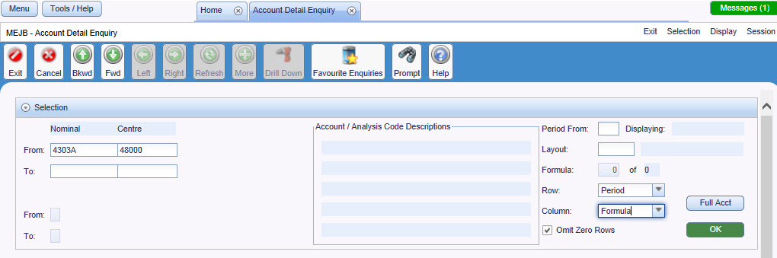

|  |  |
| --- | --- |
| Nominal | Nominal code to be enquired upon, or Wildcard ‘%’  See Points to ponder |
| Centre | Cost Centre to be enquired upon |
| Layout | Defines what columns will be displayed  See Points to ponder |
| Period From | Start period from which transactions will be included in the balances.  If left blank will default to current period |
| Period To | End period up to which transactions will be included in the balances.  If left blank will default to the end of the current financial year |
| Omit Zero Rows | If checked will not display balance if zero for a particular nominal / cost centre relationship |
| Row / Column Pick Lists | Allows the screen layout to be amended  E.g. to show the periods as columns rather than rows |

Points to ponder

Use a wildcard % in the nominal field to view totals against a specified cost centre. Balances for each nominal will be displayed on a separate row (unlike Figure 8which displays a row per month).

If a range of periods is selected, the [Next] and [Previous] buttons will ‘scroll’ through the relevant months.

Account Detail Enquiry screen

Figure 6

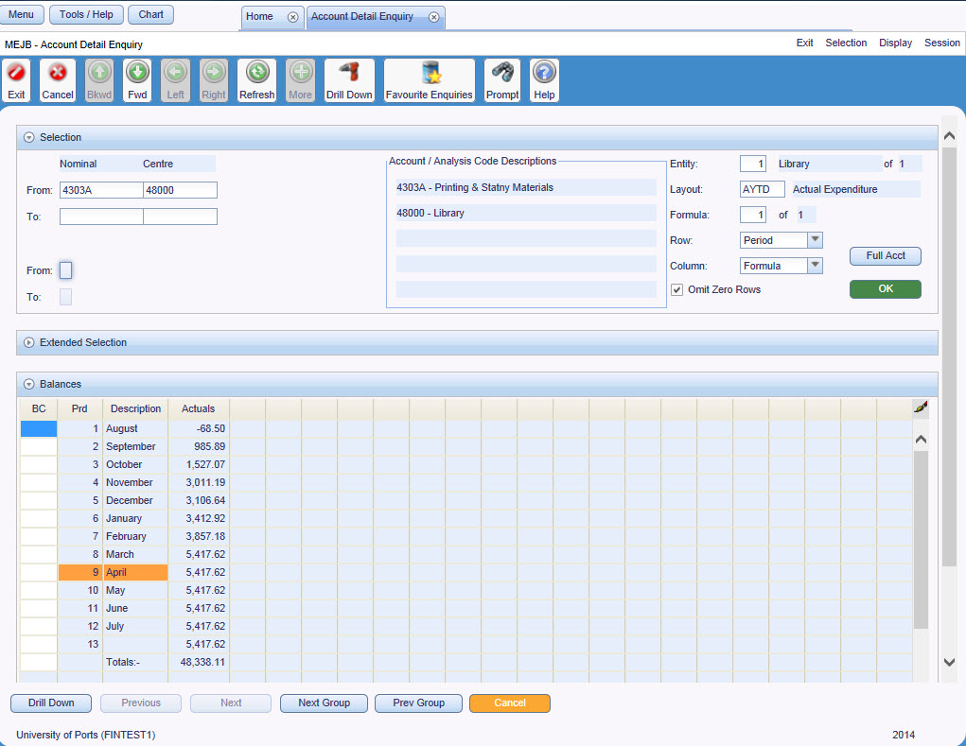

Field Chart

|  |  |
| --- | --- |
| Field | Description |
| Entity / Period | The cost centre, nominal or period for which balances are being displayed |
| From / To | Nominal and Cost Centre Ranges for these balances |
| Row / Column Pick Lists | Allows the screen layout to be amended  E.g. to show the periods as columns rather than rows |
| Period From | Start period from which transactions will be included in the balances |
| Period To | End period up to which transactions will be included in the balances |
| The screen’s repeater block will display a combination of the following fields depending on the Layout identified in the selection window. If required, the 🡪 icon will scroll to display the additional fields  See ‘Layouts’ below for a breakdown of the actual fields for the most commonly used layouts. | |
| Prd | Period |
| Description | Month name |
| Original Budget | Estimate of total expenditure/income for the year |
| Current Forecast | Current revision to the original budget |
| Variance for Year | The difference between the original budget and the current forecast |
| Actuals | Total expenditure / income |
| Committed | Total value of orders placed but not yet received |
| Goods Received | Total value of orders received but not yet paid for |
| Commits & GRNs | Combined total of the value of orders placed but not yet received and the value of orders placed but not yet received |
| Unspent Forecast | Amount of forecast not yet committed or received |
| Act % Forecast | Actuals to-date as a percentage of the current forecast |

Commonly used layouts

|  |  |
| --- | --- |
| **Layout** | **Fields Displayed** |
| AYTD | Per, Description, Actuals |
| BUDG | Per, Description, Original Budget, Current Forecast, Variance for Year, Actuals, Commits & GRNs, Unspent Forecast, Act % Forecast |
| BUD1 | Per, Description, Original Budget, Current Forecast, Variance for Year, Actuals, Committed, Goods Received, Unspent Forecast, Act % Forecast |
| YRS | Per, Description and Actuals for current and previous 5 years |

Drilling Down from the Account Detail Enquiry screen

Drilling down from an account balance enquiry run against a cost centre and nominal

Drilling down on a specific month will display the transactions (see account transaction enquiry on page 15) for the selected cost centre, nominal and period.

If the account balances screen has been accessed by originally drilling down from a profit and loss enquiry, other options may be available.

|  |  |
| --- | --- |
| **From list of:** | **Data Displayed** |
| Parent Elements | the account balances for the selected category and period for each of the elements within that parent element. |
| Element | the account balances for the selected category and period for each of the cost centres within that element. |
| Cost Centre | the account balances for that cost centre and period for each of the nominals within the selected category. |
| Nominal | the individual account transactions for that period for the selected cost centre and nominal, see Account Transactions on page 15 |

Macro Buttons

A number of macro buttons are available at the bottom of the Account Detail Enquiry screen:

|  |  |
| --- | --- |
| [Drill Down] | Opens the Transaction Details List screen for the selected period, cost centre and nominal (displaying balance class AB) |
| [Previous] | If wildcards used in cc/nom fields, will display the previous cc/nom |
| [Next] | If wildcards used in cc/nom fields, will display the next cc/nom |
| [Next Group] | Not used |
| [Extended] | Not used |
| [Cancel] | Returns to the previous screen |

Account Transaction Enquiries

The Transaction Details List screen displays a list of all the transactions for a specified cost centre, nominal, balance class and range of periods.

Location

Enduser Main Menu 🡪 Balances & Transactions 🡪 Account Transactions

The screen can also be accessed by drilling down from the account balance screen.

Selection Parameters

Figure 7

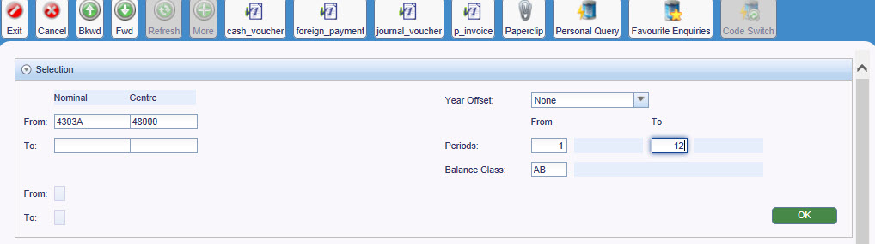

|  |  |
| --- | --- |
| Nominal Range | Nominal code to be enquired upon, or Wildcard ‘%’  See Points to ponder |
| Centre Range | Cost Centre to be enquired upon, or Wildcard ‘%’  See Points to ponder |
| Period From | Start period from which transactions will be displayed.  If left blank will default to current period |
| Period To | End period up to which transactions will be displayed.  If left blank will default to current period |
| Balance Class | Balance class to be enquired upon, or Wildcard ‘%’.  If left blank will default to balance class AB |
| Year Offset | Financial year to be enquired upon relative to the current financial year, e.g. ‘0’ indicates the current year, ‘-1’ indicates last financial year, ‘+1’ indicates next financial year. Up to 5 year’s history are available.  If left blank will default to the current financial year |

Points to ponder

If the nominal or cost centre fields are left blank or a wildcard is used, only one nominal / cost centre will be displayed on the Transaction Details screen at any given time.

The [Next Entity] button will scroll systematically through each of the relevant nominal / cost centre relationships.

Transaction Detail List Screen

Figure 8

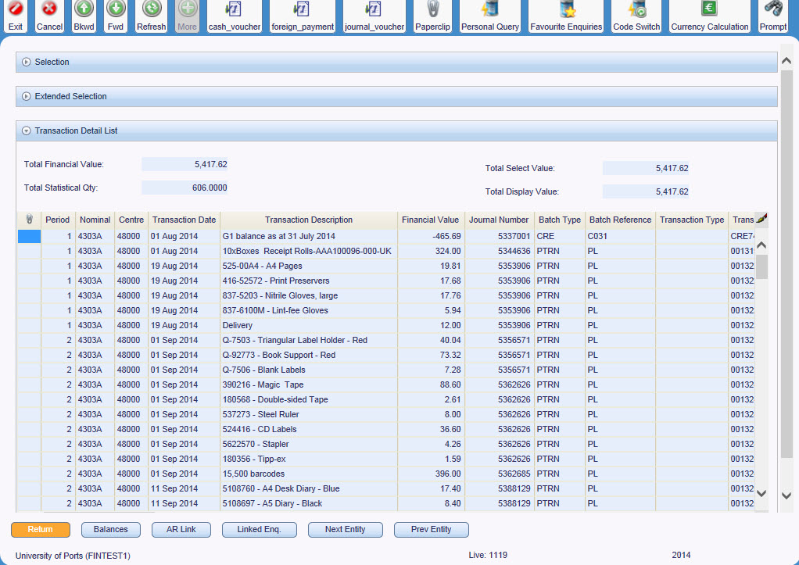

Use <Ctrl> + <W> to resizes the columns to display the data onto a single screen.

Field Chart

|  |  |
| --- | --- |
| Field | Description |
| Nominal | Nominal code for these transactions |
| Centre | Cost Centre for these transactions |
| Total Value | Total value for all transactions retrieved, for all selected periods |
| Total Display Value | Total of all values in the Value column |
| Statistical Quantity | Total of quantities from the associated purchase order/sales invoice lines |
| Total Select Value | Not used – displays the same value as Total Display Value |
| Transaction Details Tab | |
| Per | Period this transaction occurred |
| Nominal | Nominal code for this transaction |
| Centre | Cost centre for this transaction |
| Tran Date | Transaction Date – date this transaction was posted |
| Description | Transaction line description as entered by Payments or taken from the associated purchase order/sales invoice |
| Value | Value of this transaction. Negative entries are credits |
| Batch Details Tab | |
| Audit Ref | System generated reference for the batch in which this transaction was entered |
| Seq No. | Batch Sequence Number – number of this transaction within batch |
| Batch Type | Type of transaction as entered by Finance  E.g. JNL, CRE, TIL |
| Batch Ref | Ledger/module in which the transaction originates or reference number generated by Finance for this transaction  E.g. GRN – goods receipt, PL – Purchase Ledger, JNL - Journal |
| Tran Type | Not used |
| Tran Ref | Reference number generated by Finance for this transaction, e.g. Journal number |
| Recon Flag | Not used |
| Recon Code | Not used |
| Project | Not used |
| Bal Class | Balance Class for this transaction |
| Audit Details Tab | |
| Input Date | Date this transaction was entered |
| Input Operator | User id of the user who entered this transaction |
| Authorised Date | Not used |
| Statistical Quantity | Quantity for this transaction taken from the associated purchase order/sales invoice line |
| Statistical Code | ‘ST’ if a quantity exists for this transaction |
| Cost Allocation Tab – only 2 field used | |
| UOM | Unit of Measure for this transaction taken from the associated purchase order line |
| Tax | Tax code that applies to this transaction |
| Currency Details Tab – only 3 fields used | |
| Display Value | Value of this transaction. Negative entries are credits |
| Select Value | Value of this transaction. Negative entries are credits |
| Code | Currency code – GBP for GB Pounds Sterling |

|  |  |
| --- | --- |
| Analysis Codes Tab | |
| None of the fields on this tab are used | |
| Linked Enquiry Tab | |
| Code | Supplier or customer reference number for this transaction if it originates from a purchase order or sales invoice |
| Reference | Reference number for this transaction, e.g. invoice number |
| Type | Document type for the linked enquiry |
| Date | Date of the originating transaction, e.g. purchase order entry date |
| Transaction Key | Reference number generated from Transaction Ref and Batch Sequence Number |
| Company | UP for University of Portsmouth, EL for UPEL |
| Source System | Name of ledger/module in which this transaction originated |
| Linked enquiry Customer / Supplier Name | Name of the linked enquiry customer or supplier |
| Original Account Tab | |
| None of the fields on this tab are used | |
| Original Analysis Tab | |
| None of the fields on this tab are used | |
| Value Dates Tab | |
| None of the fields on this tab are used | |

Display Journal Details

From the Transaction Detail enquiry screen, the details on a journal batch can be viewed by right clicking and selecting ‘Display Journal Batch Details’, see Figure 10.

Figure 10

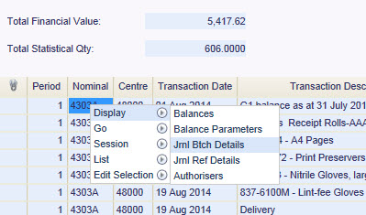

The Display Journal Details enquiry screen, see Figure 11, details all the entries with the selected journal.

Figure 11

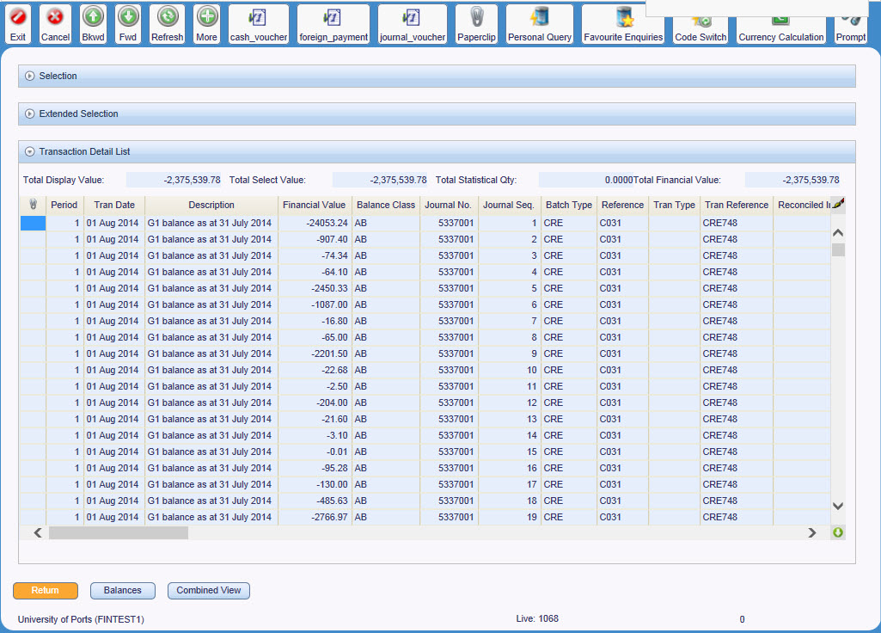

St Andrew’s Court

St Michael’s Road

Portsmouth

PO1 2PR

