e5
Split Analysis
CDR06

Version 4
July 2015
ithelp.port.ac.uk/ittraining
Twitter: @ISUOP
www.port.ac.uk/finance

Split Analysis 1
Location 1
Field Chart 1
Process to Add Split Analysis to an Order Line 2
Order Line Split Analysis Edit Macro Buttons 3

Split Analysis
Split analysis is used when the cost of an individual order line is to be split between more than one cost centre. This is used when sizeable expenditure on a single item / service is to be paid for by more than one budget.

Location
End User Main Menu Order Management Create Order

Figure 1
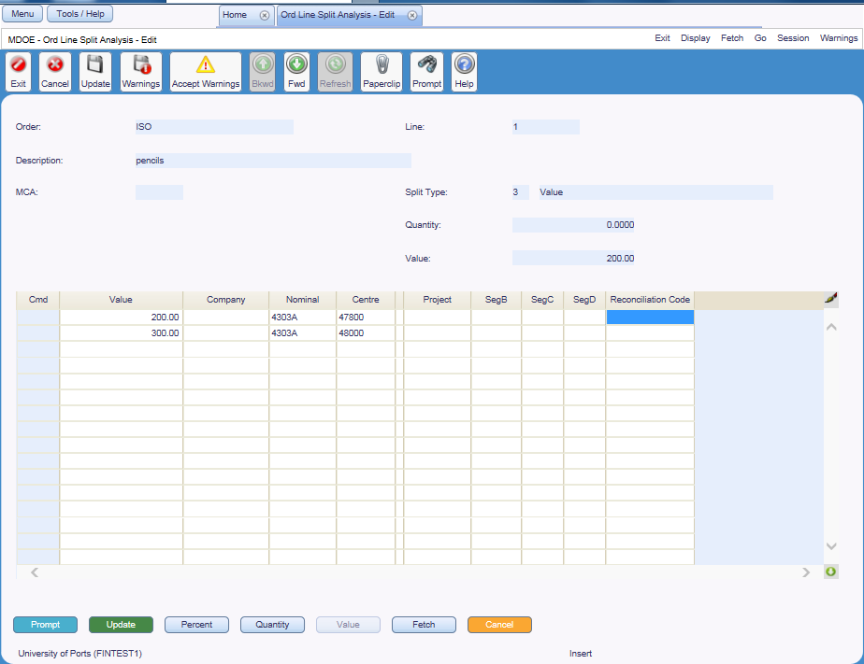

Field Chart
Field | Description
Order | Order prefixes are the characters which identify the department raising the purchase order. The prefixes are followed by a system generated number  E.g. CHM01262 – Pharmacy, BIO04325 - Biomedical order
Line | Line number to which split analysis applies
Description | Description of the item / service ordered
MCA | Not used
Split Type | Type of split analysis applied  I.e. 1 – Percentage split, 2 – Quantity split, 3 – Value split
Quantity | Standard line | Amount of the item ordered
 | Value line | Not used
Value | Standard line | Not used
 | Value line | Price of service including any non-recoverable VAT
Cmd | Lines can be deleted or copied, according to a set of rules  See CDR02 Purchase Order Processing manual
Percentage, Quantity or Value | Proportion of order line (by percentage, quantity or value as appropriate for the split analysis type) for this split analysis line
Company | Code indicating whether the order originated from the University or one of its subsidiary companies,  E.g. UP – University of Portsmouth, EL – UPEL
Nominal | Nominal code for this line  E.g. 4303A – Printing and Stationery Materials
Centre | Cost centre for this line  E.g. 41011 – Technology Faculty stores
OK | Not used
Project | Not used
Reconciliation Code | Not used

Process to Add Split Analysis to an Order Line
- Leave Nominal and Cost Centre blank
- Enter split analysis | Enter the relevant code to define the type of split analysis to be applied:  ‘1’ - split by percentage  ‘2’ - split by quantity  ‘3’ - split by value
- Select order line | Select any field on the relevant order line
- [S/A] | To access the Order Line Split Analysis screen
- Enter budgetary information | The mandatory fields are:  Percentage / Quantity / Value (as appropriate for the split analysis type)  Nominal and Centre
- If appropriate, repeat for next order line
- Return to order | Use [Cancel] to return to the order

Order Line Split Analysis Edit Macro Buttons
- [Prompt] | Not used on this screen
- [Update] | Save changes to the order
- [Percent] | Not used
- [Quantity] | Not used
- [Value] | Not used
- [Fetch] | Not used
- [Cancel] | Returns to order entry screen having ‘saved’ split analysis detail

Information Services
St Andrew’s Court
St Michael’s Road
Portsmouth
PO1 2PR

