e5
Revisions
CDR04

Version 4
July 2015
ithelp.port.ac.uk/ittraining
Twitter: @ISUOP
www.port.ac.uk/finance

Purchase Order Revisions 1
Processing Revisions 1
Order Status codes 1
Enquiry - Order Line List Screen 3
Navigation Options to access the Order Line List Enquiry screen 3
Field Chart 4
Macro Buttons and Navigation from Order Line List screen 5
Revising Data on an Order 6
Status Restrictions 6
Process 6
Points to Ponder 6
Re-authorisation 6
Warning – ‘Due date is less than current GL date’ 7
Revision Values 7
Adding an Order Line 8
Status Restrictions 8
Process 8
Points to Ponder 8
Re-authorisation 8
Warning – ‘Due date is less than current GL date’ 8
Revision Values 8
Cancelling an Order Line / Whole Order 9
Status Restrictions 9
Process 9
Points to Ponder 9
Re-authorisation 9
Cancelling a whole order by cancelling all the order lines 9
Cancelling an order line with status of Await Delivery or Await Invoice 9
Warning – ‘Due date is less than current GL date’ 10
Cancelling a Goods Receipt 11
Status Restrictions 11
Process 11
Points to Ponder 11
Status changes 11
Clearing a ‘Matched’ Goods Receipt 12
‘Matched’ Goods Receipt/s 12
Process 12
Point to Ponder 13
Error messages 13
Completing a Partially Receipted Order Line 14
Status Restrictions 14
Process 14
Invoice(s) outstanding 14
No invoice(s) outstanding 15
Point to Ponder 15
Error messages 15

Purchase Order Revisions
A variety of situations can arise that will require an order entered on COA e52 to be revised, e.g. a data input error or a change in goods / services required, or when undertaking routine validation.
The types of revisions that can be recorded on COA e52 are:

Revising data on an order | Individual fields on the Purchase Order Enter / Revise screen can be amended  (see page 6)
Adding an order line | Additional order line can be added to an existing order  (see page 8)
Cancelling an order line / whole order | An individual order line, that is no longer required, can be cancelled  An entire order can be cancelled by cancelling all order lines  (see page 9)
Cancelling a goods receipt | A goods receipt, that is no longer required, can be cancelled if not complete  (see page 11)
Completing a partially receipted order line | A partially receipted order line can be completed to indicate that no further goods / services are going to be delivered  (see page 14)

Processing Revisions
Each revision in COA e52 will be processed in order of submission and therefore could be waiting in a queue which may take several minutes to complete. This may need to be taken into consideration when carrying out a number of revisions to an order,
e.g. when cancelling two order lines on an order, the system will only allow the second order line to be cancelled after it has finished processing the first.

Order Status codes
Status codes give an indication of the stage an order has reached in the purchase order cycle. The same codes are also used to describe the status of individual order lines.
There are restrictions on the revisions which can be made to orders, order lines and goods receipts and these are based upon their status. These restrictions are detailed within the relevant sections of this document.
There are 6 valid statuses, which may have different meanings in relation to Orders and Order Lines:

Status | Referring to an Order | Referring to an Order Line
Held | The order is waiting to be authorised. It has either recently been created and not yet authorised or key fields on the order have been revised which require the order to be re-authorised
Outstanding | The order has been authorised but, as yet, no receipts have been entered | No receipts have yet been made for the order line
Await Delivery | The order has been authorised and receipt(s) have been entered for some, but not all of the order | A partial receipt has been entered for the order line but a portion of the line is still outstanding
Await Invoice | The order has been authorised, no further deliveries are expected for any of the lines on the order but the supplier’s invoice has not yet been processed | The line has been fully receipted. The University is not expecting any further deliveries for this order line
Complete | The order has been authorised, all deliveries have been received and the supplier’s invoice has been paid | The line has been fully receipted and an invoice has been paid for this order line
Cancelled | The order has been cancelled by a COA e52 user

Enquiry - Order Line List Screen
In view mode, the Purchase Order Enter/Revise screen allows the order lines to be viewed exactly as they were entered onto the system. This screen can be used to enquire on an order prior to any revisions being recorded.
Menu Order Management Order Enquiry/Copy

Navigation Options to access the Order Line List Enquiry screen
Order List screen Right click Display Lines
Order List screen Menu bar Display Lines
Order List screen [Lines]

Figure 1
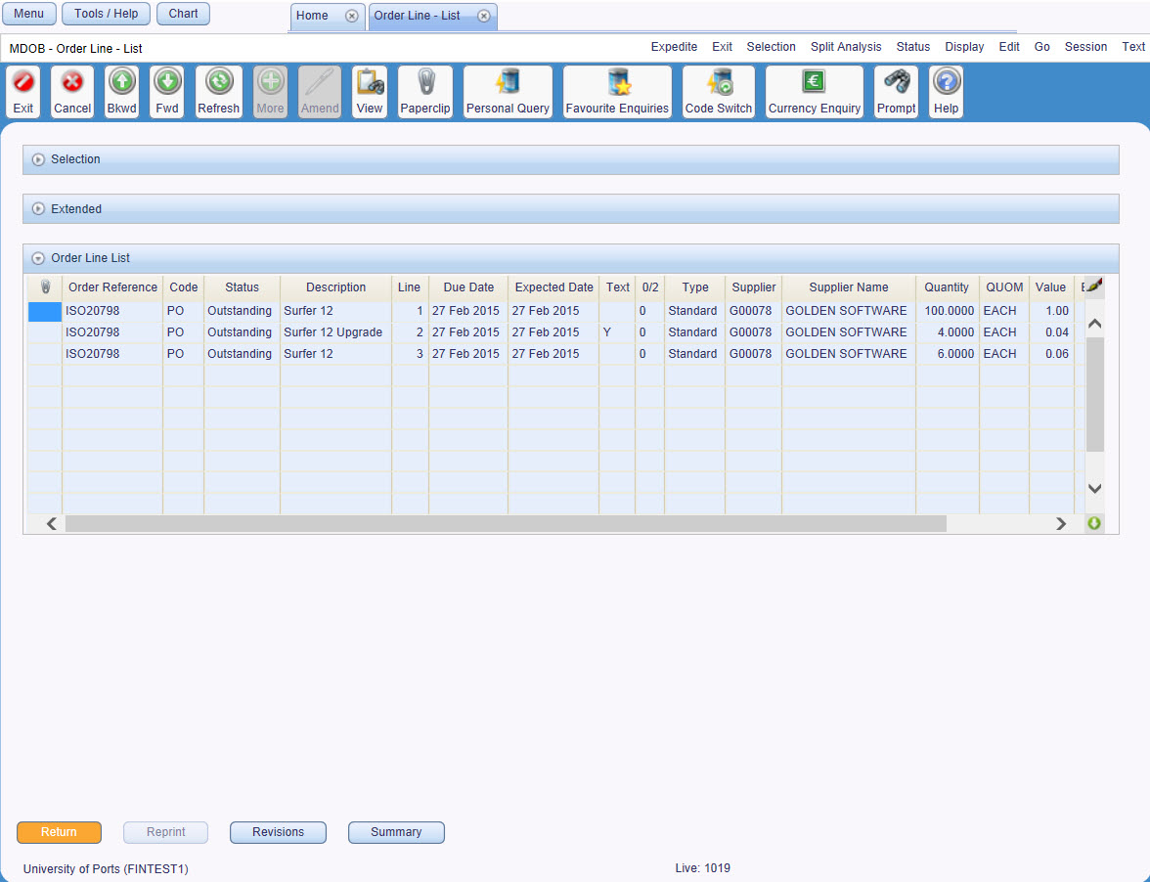

Field Chart
Field | Description
Primary Details Tab
Reference | Order prefixes are the characters which identify the department raising the purchase order. The prefixes are followed by a system generated number  E.g. CHM01262 – Pharmacy, BIO04325 - Biomedical order
Code | Code indicating the type of order  E.g. PO – Normal Purchase Order (printed), CO – Confirmation Order (not printed)
Status | Status of this order line  E.g. Await Invoice
Description | Description of this item / service ordered
Line | Line number of this order line
Due Date | Date this order was placed or the delivery is expected
Expected Date | Not used – defaults to Due Date
Text | ‘Y’ indicates that Line Text exists for this order line
0/2 | Code for the line type  I.e. 0 – Standard, 2 – Value
Type | Line type description  I.e. Standard or Value
Supplier | Unique number for the supplier providing the goods / services  E.g. 000136 – Office Depot
Supplier Name | Supplier name relating to the supplier code  E.g. Office Depot
Quantity | Standard line | Quantity of the item ordered
 | Value line | Not used
QUOM | Standard line | Unit of Measure. Code used on Standard lines indicating how the items are counted / measured  E.g. PALL – Pallet, BX12 – Box of 12
 | Value line | Not used
Value | Standard line | Not used
 | Value line | Value of service including any non-recoverable VAT
Base Price | Standard line | Price of item, per unit of measure, including any non-recoverable VAT
 | Value line | Not used
Revision Number | Number of times this order has been revised

Macro Buttons and Navigation from Order Line List screen
- [Return] | Returns to the previous screen
- [Extended] | Not used
- [Reprint] | Not used
- [Revisions] | Not used
- [Summary] | Opens the order summary screen (see CDR01 Introduction and Navigation manual)

Revising Data on an Order

Status Restrictions
No revisions can be recorded on orders or order lines with a status of Complete or Cancelled.
The following is a list of the fields in the Order Header tab that can be amended:
Address Number
Delivery Location
Originator
Printing radio buttons

The following is a list of the fields in the Order Lines and Invoice Supplier tabs that can be amended:
Line Description | UOM * | Quantity ⁺⁺
Due Date | Price * | Service Value ⁺⁺
Expected Date | Nominal *
Commit Date | Cost Centre *
Invoice Supplier | Split Analysis *
 | Company *

* can’t be revised if the status is Await Delivery or Await Invoice.
++ can’t be revised if the status is Await Delivery or Await Invoice unless the new quantity / value is greater than the quantity / value already received.

Process
- Identify order |  | Identify the order using the Order List screen
- Enter revision mode |  | Right click Edit Revise
 | - Revise dates if required | See Points to Ponder
 | - Amend data | Overtype fields as appropriate
- Update order |  |  | or [Update] to save the changes to the order

Points to Ponder

Re-authorisation
An order must be re-authorised if data in one of the key fields is amended, i.e. Price, Value, Qty, Cost Centre or Nominal.
Orders raised as Printed Purchase Orders (PO) will then be re-printed.

Warning – ‘Due date is less than current GL date’
Orders can not be revised if the Due, Expected and Commit dates are earlier than today.
To remove the warning message, clear the three date fields; do not use the 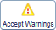. Accept Warnings icon from the status bar.

Revision Values
When an order has been revised, a user can view these changes by selecting one of the highlighted fields and using [Revision Values]. The ‘Revision History’ will show the value, user, date and time the revision was made.

Adding an Order Line

Status Restrictions
No revisions can be recorded on orders or order lines with a status of Complete or Cancelled.

Process
- Identify order |  | Identify the order using the Order List screen
- Enter revision mode |  | Right click Edit Revise
 | - Revise dates if required | See Points to Ponder
 | - Add new order line(s) | Complete the relevant fields for each new order line(s)
- Update order |  |  | or [Update] to save the changes to the order

Points to Ponder

Re-authorisation
An order must be re-authorised if data in one of the key fields is amended, i.e. Price, Value, Qty, Cost Centre or Nominal.
Orders raised as Printed Purchase Orders (PO) will then be e-mailed.

Warning – ‘Due date is less than current GL date’
Orders can not be revised if the Due, Expected and Commit dates are earlier than today.
To remove the warning message, clear the three date fields; do not use the Accept Warnings icon from the status bar.

Revision Values
When an order has been revised, a user can view these changes by selecting one of the highlighted fields and using [Revision Values]. The ‘Revision History’ will show the value, user, date and time the revision was made.

Cancelling an Order Line / Whole Order

Status Restrictions
No revisions can be recorded on orders or order lines with a status of Complete or Cancelled.
Additionally, no order lines can be cancelled if their status is Await Delivery or Await Invoice.

Process
- Identify order |  | Identify the order using the Order List screen
- Display lines |  | [Lines]  Or  Right click Display Lines
 | - Select line to be cancelled | Highlight any field on the line to be cancelled
 | - Cancel line | Right Click Status Revise Cancelled  The Purchase Order Enter/Revise screen will open
- Update order |  |  | or [Update] to save the changes to the order

Points to Ponder

Re-authorisation
An order must be re-authorised if data in one of the key fields is amended, i.e. Price, Value, Qty, Cost Centre or Nominal.
Orders raised as Printed Purchase Orders (PO) will then be re-printed.

Cancelling a whole order by cancelling all the order lines
If all the order lines on an order are cancelled, the whole order’s status changes to ‘Cancelled’.

Cancelling an order line with status of Await Delivery or Await Invoice
In order to cancel an order line with a status of Await Delivery or Await Invoice, the goods receipts must be cancelled first, see page 11.

Warning – ‘Due date is less than current GL date’
Orders can not be revised if the Due, Expected and Commit dates are earlier than today.
To remove the warning message, clear the three date fields; do not use the Accept Warnings icon from the status bar.

Cancelling a Goods Receipt

Status Restrictions
No revisions can be recorded on orders or order lines with a status of Complete or Cancelled.
Additionally, goods receipts can only be cancelled if a corresponding invoice has not yet been processed by Payments, i.e. the order line status is Await Delivery or Await Invoice and the Goods Receipt Status is Outstanding.

Process
- Identify order |  | Identify the order using the Order List screen
- Display lines |  | [Lines]  Or  Right click Display Lines
 | - Select line to be processed | Highlight any field on the line for which the goods receipt is to be cancelled
 | - Display goods receipts | Right Click Display Goods Receipts
 | - Select receipt to be cancelled | Highlight any field on the line to be cancelled
 | - Cancel goods receipt | Right Click Edit Cancel  The Goods Receive/Return or GRN Service Value Edit screen will open
- Update order |  |  | or [Update] to save the changes to the order

Points to Ponder

Status changes
Cancelling a goods receipt will change the status of the associated order line:
If there are no more receipts for the given order line, the order line status will change to ‘Outstanding’ once processing has completed.
If other (non cancelled) receipts exist for the order line, the order line status will change to ‘Await Delivery’.

Clearing a ‘Matched’ Goods Receipt

‘Matched’ Goods Receipt/s
A goods receipt may have a status of ‘matched’, if the goods receipt/s and the invoice price differ. The system will ‘match’ the goods receipt/s.
The ‘matched’ goods receipt/s will not allow the order to be ‘completed’ until the goods receipt/s for the outstanding monies or quantity has been received.
If there is no invoice left to be received, the user will need to manually clear the ‘matched’ goods receipt/s.

Figure 2

Process

- Identify order |  | Identify the order using the Order List screen
 | - Display goods receipts | Right Click Display Goods Receipts
 | - Select matched receipt | Highlight matched receipt
 | - Find outstanding quantity/value  - Insert Value return  or  Return  - Identify order | Identify the value/quantities outstanding, by noting the ‘Invoice quantity’ or ‘Value outstanding’ field/s  ApplicationInsertValue Return or Return  Fetch  On the correct line, input the value/quantity in the ‘Credit quantity’ or ‘Value’ field/s
Update order |  |  | or [Update] to save the changes to the order
The order then can be completed, see page 14.

Point to Ponder

Error messages
The receipt will always show as matched but a new ‘outstanding’ goods receipt will appear for the amount cleared.

Completing a Partially Receipted Order Line

Status Restrictions
Completing partially receipted order lines only applies to order lines with a status of Await Delivery.

Process
There are two processes for completing an order which depend on the ‘state’ of the order line, they are:
Invoice(s) outstanding, i.e. the goods receipt status is Outstanding because some goods / services have been received but not yet paid for.
Or
No Invoice(s) outstanding, i.e. the goods receipt status is Complete because all goods / services received have been paid for.

Invoice(s) outstanding
- Identify order |  | Identify the order using the Order List screen
- Display lines |  | [Lines]  Or  Right click Display Lines
 | - Select line to be processed | Highlight any field on the line for which the goods receipt is to be marked as complete
 | - Display goods receipts | Right Click Display Goods Receipts
 | - Select appropriate receipt | Highlight any field on the line to be marked as complete
 | - Amend goods receipt | Right Click Edit Amend  The Goods Receive/Return or GRN Service Value Edit screen will open
 | - Complete goods receipt | Enter ‘Y’ in the ‘Complete?’ field
- Update Warnings |  |  | to clear a warning and allow further processing of the order

No invoice(s) outstanding
- Identify order |  | Identify the order using the Order List screen
- Display lines |  | [Lines]  Or  Right click Display Lines
 | - Select line to be processed | Highlight any field on the line for which the goods receipt is to be marked as complete
 | - Amend goods receipt | Right Click Edit Amend  The Goods Receive/Return or GRN Service Value Edit screen will open
 | - Complete line | Right Click Status Revise Complete  The Purchase Order Enter/Revise screen will open
- Update |  |  | or [Update] to save the changes

Point to Ponder

Error messages
If any error messages are displayed, e.g. ‘Errors exist on the Order Line’, contact the Finance Systems COA e52 Team.

St Andrew’s Court
St Michael’s Road
Portsmouth
PO1 2PR

